The Joy Luck Club Reading Guide 1 – “The Joy Luck Club”
NAME: DATE: PERIOD:
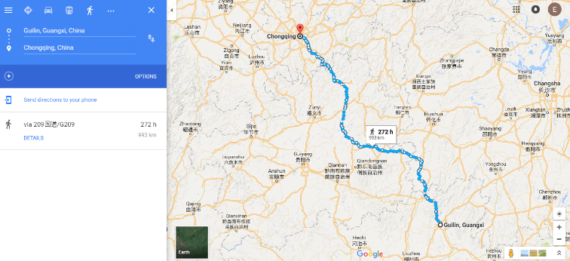
*Note that, according to Google Maps, walking from Kweilin to Chungking would take 272 hours.

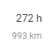

- As you read this chapter, try to place the following events on the timeline.
• The Joy Luck Club is founded in China. | • Suyuan Woo dies of an aneurysm.
• The Joy Luck Club is founded in San Francisco. | • The Kweilin (Guilin) Massacre
• The end of World War II | •Suyuan Woo loses her first two babies.
• Jing-Mei (June) Woo is born. | • The beginning of World War II
(Note that on page 27, Jing-Mei [June] says that she is thirty-six years old.]

- What do you think is the purpose of the myth about woman and the swan at the beginning of the story? (AUTHOR’S PURPOSE)

- What imagery in this story sticks out to you? (Copy down a quotation and cite it.) How does it make you feel? What does it make you think? (IMAGERY)

- Summarize the story that Suyuan Woo tells her daughter Jing-Mei about her escape from Kweilin to Chungking. Why does she tell her this? (CHARACTERIZATION)

- What kinds of conflict exist between the mothers in the Joy Luck Club and their daughters? (CONFLICT)
- What kinds of conflicts exist between the women in the Joy Luck Club (the older generation)? (CONFLICT)

- On page 21, the narrator (June/Jing-Mei) introduces her mother’s story about her escape from Kweilin by saying, “Over the years, she told me the same story, except for the ending, which grew darker, casting long shadows into her life, and eventually into mine.” Analyze this quotation. (THEME)

- Explain the significance of these two details from the minutes of the previous meeting (pages 28-9): 1) the Joy Luck Club was investing in the Subaru company and 2) “the red bean soup was especially delicious.” (INFERENCE)

Detail #1:

Detail #2:

- What similarities do you see between this story and the Odyssey? (CONNECTIONS BETWEEN LITERATURE)

