Dracula Reading Guide – Chapter 25 (13 pages)
Before Reading:
- “Hotch-pot” is a legal term for a group of people combining their assets into a pool and then dividing them equally among the members.
- “The Orient Express” was a famous train that went from Western Europe to Eastern Europe.
- “M.S.” is an abbreviation for “manuscript.”

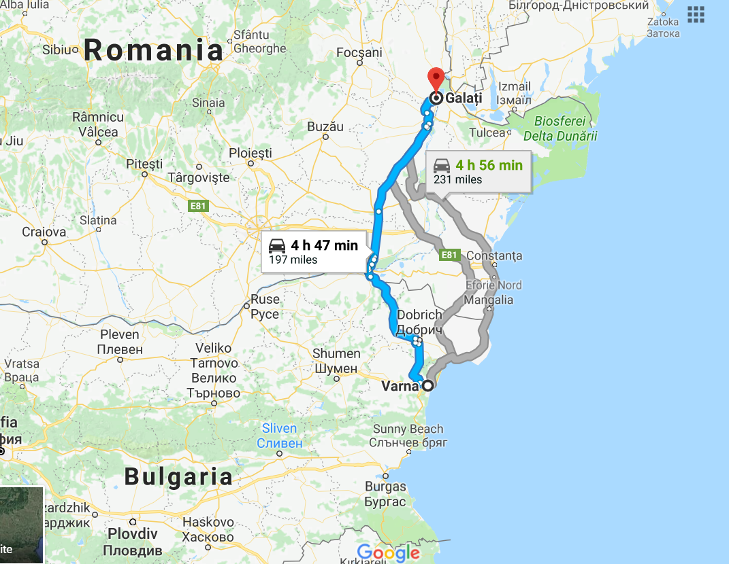
This is a distance of about 200 miles –a lengthy journey in this time.
Varna is where the vampire hunters believe Dracula’s ship will land. They arrive there early and wait for him.
Galatz (or Galati) is where Dracula’s ship actually lands. They changed course and went up the river.
Questions:
- What does Mina ask the men to promise to do for her?

- How does the group of vampire hunters arrange to travel to Eastern Europe and monitor Dracula’s arrival?

- On page 291, Mina says, “‘Something is shifting from me in some strange way, and I feel freer than I have been of late!’” Dr. Seward then says, “The three younger men looked happier at the moment as they seemed to realise the significance of her words; but Van Helsing and I, turning to each other, met each a grave and troubled glance.” Why are Val Helsing and Seward worried about Mina’s statement that she is feeling better?

