Dracula Reading Guide – Chapter 1 (11 pages)
Before Reading:
- Dracula is what is called an epistolary novel (a novel told in a series of documents such as letters or diary entries, as opposed to one told by a narrator).
- Shorthand is a method of writing using abbreviations (helpful in a time prior to the widespread use of recording technology).
- Here is a map of Jonathan Harker’s journey:
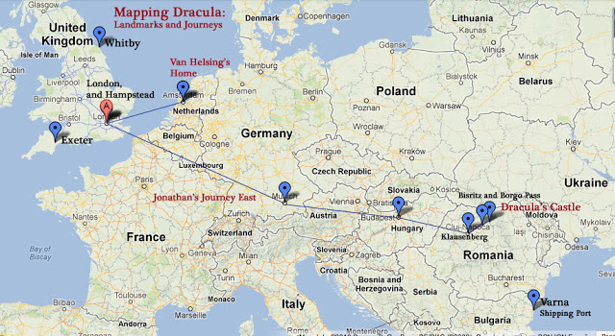
- When Harker calls the dish “thirsty,” he means that it is spicy and he had to drink a lot of water.
- A diligence is a horse-drawn carriage.
- Goitre is a disease that makes the throat swell up because of a deficiency in minerals.
- “Herr” is the German word for “mister” and a term of respect.

Go to the class website (www.mschapmansclass.com) for more background information and pictures to help you visualize what’s happening in this chapter.

(questions on the back)

Questions:
- Based on the quotations below, what is Jonathan Harker’s attitude towards the people of Eastern Europe?
  - “The impression I had was that we were leaving the West and entering the East […]” (1)
  - “I read that every superstition in the world is gathered into the horseshoe of the Carpathians, as if it were the centre of some sort of imaginative whirlpool; if so my stay may be very interesting.” (2)
  - “It seems to me that the further [*note that he uses this word incorrectly! it should be “farther”] east you go the more unpunctual are the trains. What ought they to be in China?” (2)
  - “The women looked pretty, except when you got near them, but they were very clumsy about the waist.” (2) [What Harker means here is that women in Eastern Europe do not practice wearing corsets, as Victorian women in England at the time did, which mutilated their abdomens to create tiny waists.]

- How does the author create an atmosphere of suspense in this chapter? (*Hint – talk about his use of foreshadowing to create suspense. You could also – but you do not have to – focus on either the Romanian people’s interactions with Jonathan Harker or on the setting itself.) Support your answer with two quotations from the text, and highlight those quotations.

