The Most Terrifying Thing About Ebola

The disease threatens humanity by preying on humanity.
By Benjamin Hale
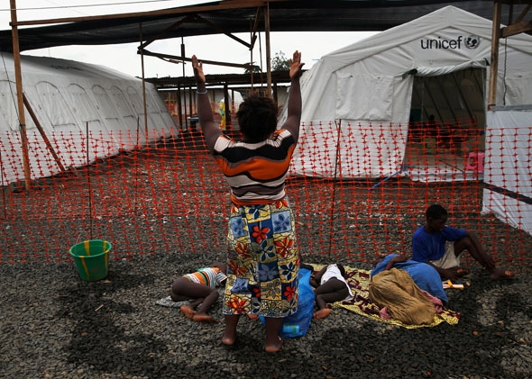
(1) As the Ebola epidemic in West Africa has spiraled out of control, affecting thousands of Liberians, Sierra Leonians, and Guineans, and threatening thousands more, the world’s reaction has been glacially, lethally slow. Only in the past few weeks have heads of state begun to take serious notice. To date, the virus has killed more than 2,600 people. This is a comparatively small number when measured against much more established diseases such as malaria, HIV/AIDS, influenza, and so on, but several factors about this outbreak have some of the world’s top health professionals gravely concerned:
Suspected Ebola patient Finda “Zanabo” prays over her sick family members before being admitted to the Doctors Without Borders Ebola treatment center on Aug. 21, 2014, near Monrovia, Liberia.

- (2) Its kill rate: In this particular outbreak, a running tabulation suggests that 54 percent of the infected die, though adjusted numbers suggest that the rate is much higher.
- (3) Its exponential growth: At this point, the number of people infected is doubling approximately every three weeks, leading some epidemiologists to project between 77,000 and 277,000 cases by the end of 2014.
- The gruesomeness with which it kills: by hijacking cells and migrating throughout the body to affect all organs, causing victims to bleed profusely.
- (4) The ease with which it is transmitted: through contact with bodily fluids, including sweat, tears, saliva, blood, urine, semen, etc., including objects that have come in contact with bodily fluids (such as bed sheets, clothing, and needles) and corpses.
- (5) The threat of mutation: Prominent figures have expressed serious concerns that this disease will go airborne, and there are many other mechanisms through which mutation might make it much more transmissible.
(6) Terrifying as these factors are, it is not clear to me that any of them capture what is truly, horribly tragic about this disease.
(7) The most striking thing about the virus is the way in which it propagates. True, through bodily fluids, but to suggest as much is to ignore the conditions under which bodily contact occurs. Instead, the mechanism Ebola exploits is far more insidious. This virus preys on care and love, piggybacking on the deepest, most distinctively human virtues. Affected parties are almost all medical professionals and family members, snared by Ebola while in the business of caring for their fellow humans. More strikingly, 75 percent of Ebola victims are women, people who do much of the care work throughout Africa and the rest of the world. In short, Ebola parasitizes our humanity.
(8) More than most other pandemic diseases (malaria, cholera, plague, etc.) and more than airborne diseases (influenza, swine flu, H5N1, etc.) that are transmitted indiscriminately through the air, this disease is passed through very minute amounts of bodily fluid. Just a slip of contact with the infected party and the caregiver herself can be stricken.
(9) The images coming from Africa are chilling. Little boys, left alone in the street without parents, shivering and sick, untouchable by the throngs of people around them. Grown men, writhing at the door to a hospital, hoping for care as their parents stand helplessly, wondering how to help. Mothers and fathers, fighting weakness and exhaustion to move to the edge of a tent in order to catch a distant, final glimpse of a get-well video that their children have made for them.
(10) If Ebola is not stopped, this disease can destroy whole families within a month, relatives of those families shortly thereafter, friends of those relatives after that, and on and on. As it takes hold (and it is taking hold fast), it cuts out the heart of family and civilization. More than the profuse bleeding and high kill rate, this is why the disease is terrifying. Ebola sunders the bonds that make us human.
(11) Aid providers are now working fastidiously to sever these ties themselves, fighting hopelessly against the natural inclinations that people have to love and care for the ill. They have launched aggressive public information campaigns, distributed updates widely, called for more equipment and gear, summoned the military, tried to rein in the hysteria, and so on. Yet no sheet of plastic or latex can disrupt these human inclinations.
(12) Such heroic efforts are the appropriate medical response to a virulent public health catastrophe. The public health community is doing an incredible job, facing unbelievable risks, relying on extremely limited resources. Yet these efforts can only do half of the work. Infected parties—not all, to be sure, but some (enough)—cannot abide by the rules of disease isolation. Some will act without donning protective clothing. Some will assist without taking proper measures. And still others will refuse to enter isolation units because doing so means leaving their families and their loved ones behind, abandoning their humanity, and subjecting themselves to the terror of dying a sterile, lonely death.
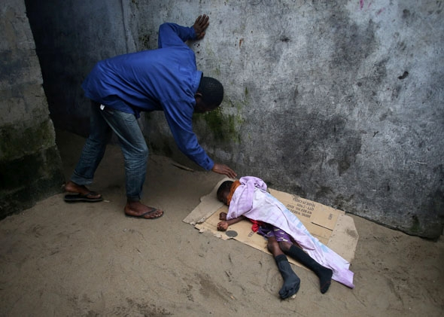
(13) It is tempting, at these times, to focus on the absurd and senseless actions of a few. One of the primary vectors in Sierra Leone is believed to have been a traditional healer who had been telling people that she could cure Ebola. In Monrovia a few weeks back, angry citizens stormed a clinic and removed patients from their care. “There is no Ebola!” they are reported to have been shouting. More recently, the largest newspaper in Liberia published an article suggesting that Ebola is a conspiracy of the United States, aimed to undermine Africa. And, perhaps even more sadly, a team of health workers and journalists was just brutally murdered in Guinea. It is easy, in other words, to blame the spread on stupidity, or illiteracy, or ritualism, or conspiracy theories, or any number of other irrational factors.
A man checks on a very sick Saah Exco, 10, in a back alley of the West Point slum on Aug. 19, 2014, in Monrovia, Liberia.
(14) But imagine: You are a parent whose child has suddenly come ill with a fever. Do you cast your child away and refuse to touch him? Do you cover your face and your arms? Stay back! Unclean! Or do you comfort your child when he asks for you, arms outstretched, to make the pain go away?
(15) Imagine: You live in a home with five other family members. Your sister falls ill, ostensibly from Ebola, but possibly from malaria, typhoid, yellow fever, or the flu. You are aware of the danger to yourself and your other family members, but you have no simple means to move her, and she is too weak to move herself. What do you do?
(16) Imagine: You are a child of 5 years old. Your mother is sick. She implores you to back away. But you are scared. What you need, more than anything, is a hug and a cry.
(17) Who can blame a person for this? It is a terrible, awful predicament. A moral predicament. To stay, comfort, and give love and care to those who are in desperate need, or to shuttle them off into an isolation ward, perhaps never to see them again? What an inhumane decision this is.
(18) What makes the Ebola virus so terrifying is not its kill rate, its exponential growth, the gruesome way in which it kills, the ease of transmission, or the threat of mutation, but rather that people who care can do almost nothing but sit on the sidelines and watch.
* * *
(19) Many have asked whether Ebola could come here, come West. (The implication, in its way, is crass—as if to suggest that we need not be concerned about a tragedy unless it poses a threat to us.) We have been reassured that it will never spread widely here, because our public health networks are too strong, our hospitals too well-stocked. The naysayers may be right about this. But they are not right that it does not pose a threat to us.
(20) But imagine: You are a parent whose child has suddenly come ill with fever. Do you cast your child away?
(21) For starters, despite the pretense, the West is not immune from absurd, unscientific thinking. We have our fair share of scientific illiteracy, skepticism, ritualism, and foolishness. But beyond this, it is our similarities, not our differences, that make us vulnerable to this plague. We are human. Every mechanism we have for caring—touching, holding, feeding, playing, warming, comforting, caressing—every mechanism that we use to bind us to our families and our neighbors, is preyed upon by Ebola. We cannot seal each other into hyperbaric chambers and expect that once we emerge, the carnage will be over. We are humans, and we will care about our children and our families even if it means that we may die in doing so.
(22) The lesson here is a vital one: People do not give up on humanity so very easily. Even if we persuade all of the population to forgo rituals like washing the dead, we will not easily persuade parents to keep from holding their sick children, children from clinging to their ailing parents, or children from playing and wrestling and slobbering all over one another. We tried to alter such behaviors with HIV/AIDS. A seemingly simple edict—“just lay off the sex with infected parties”—would seem all that is required to halt that disease. But we have learned over the decades that people do not give up sex so readily.
(23) If you think curtailing sex is hard, love and compassion will be that much harder. Humans will never give this up—we cannot give this up, for it is fundamental to who we are. The more that medical personnel require this of people without also giving them methods to manifest care, the more care and compassion will manifest in pockets outside of quarantine. And the more humanity that manifests unchecked, the more space this virus has to grow. Unchecked humanity will seep through the cracks and barriers that we build to keep our families safe, and if left to find its own way, will carry a lethal payload.
(24) The problem is double-edged. Ebola threatens humanity by preying on humanity. The seemingly simple solution is to destroy humanity ourselves—to seal everything off and let the disease burn out on its own. But doing so means destroying ourselves in order to save ourselves, which is no solution at all.
(25) We must find a method of caring without touching, of contacting without making contact. The physiological barriers are, for the time being, necessary. But we cannot stop people from caring about one another, so we must create, for the time being, mechanisms for caring. Since we will never be able to beat back humanity, we must coordinate humanity, at the family level, the local level, and the global level.
(26) The only one way to battle a disease that affixes itself parasitically to our humanity is to overwhelm it with greater, stronger humanity. To immunize Africa and the rest of the world with a blast of humanity so powerful that the disease can no longer take root. What it will take to beat this virus is to turn its most powerful vehicle, our most powerful weapon, against it.
(27) Here are some things we can do:
(28) Donate to the great organizations that are working tirelessly to bring this disease under control. They need volunteers, medical supplies, facilities, transportation, food, etc. Share information about Ebola, so people will learn about it, know about it, and know how to address it when it comes. And inform and help others. It is natural at a time of crisis to call for sealing the borders, to build fences and walls that separate us further from outside threats. But a disease that infects humanity cannot easily be walled off in this way. Walling off just creates unprotected pockets of humanity, divisions between us and them: my family, your family; that village, this village; inside, outside.
* * *
(29) One final thing.
(30) When Prince Prospero, ill-fated protagonist of Edgar Allan Poe’s story “The Masque of the Red Death,” locked himself in his castle to avoid a contagion that was sweeping his country—a disease that caused “profuse bleeding at the pores”—he assumed mistakenly that the only reasonable solution to his problem was to remove himself from the scene. For months he lived lavishly, surrounded by courtiers, improvisatori, buffoons, musicians, and wine, removed from danger while the pestilence wrought havoc outside.
(31) As with much of Poe’s writing, Prospero’s tale does not end well. For six months, all was calm. He and his courtiers enjoyed their lives, secure and isolated from the plague laying waste to the countryside. Then, one night during a masquerade ball, the Red Death snuck into the castle, hidden behind a mask and a cloak, to afflict Prospero and his revelers, dropping them one by one in the “blood-bedewed halls.” Prospero’s security was a façade, leaving darkness and decay to hold “illimitable dominion over all.” The eventual intrusion that would be his undoing foretells of a danger in believing that we can keep the world’s ills at bay by keeping our distance.
(32) If we seek safety by shutting out the rest of the world, we are in for a brutally ugly awakening. Nature is a cruel mistress, but Ebola is her cruelest, most devious trick yet.

“The Most Terrifying Thing About Ebola” Reading Quiz

- The author begins the article by…
- stating his position on a controversial issue.
- summarizing the problem that the rest of the piece will address.
- telling an anecdote to illustrate a point.
- asking the reader to consider several unanswered questions.

- The word “gravely” in paragraph 1 has a connotation of…
- death
- misfortune
- strength
- struggle

- Which of the following statements from the article best captures the author’s thesis?
- “As the Ebola epidemic in West Africa has spiraled out of control, affecting thousands of Liberians, Sierra Leonians, and Guineans, and threatening thousands more, the world’s reaction has been glacially, lethally slow.” (P 1)
- “[…] several factors about this outbreak have some of the world’s top health professionals gravely concerned […]” (P 1)
- “This virus preys on care and love, piggybacking on the deepest, most distinctly human virtues.” (P 7)
- “Nature is a cruel mistress, but Ebola is her cruelest, most devious trick yet.” (P 32)

- What is the effect of the author’s use of parallel structure in paragraph 11?
- It creates a poetic tone.
- It suggests the fight against Ebola is hopeless.
- It emphasizes how hard the aid workers have tried to stop Ebola.
- It explains the conflict between the aid workers and the victims.

- Throughout the article, the author personifies the Ebola disease as…
- deceptive
- mysterious
- evil
- misunderstood

- The author builds his argument in all of the following ways except…
- using the second-person to put the reader in the position of those affected by Ebola.
- giving facts about the disease.
- describing images of people suffering.
- quoting statements from expert scientists and doctors who work with Ebola.

- What kind of irony is present in the article?
- situational – the people who care for others with Ebola are most likely to become infected themselves
- dramatic – the people described in the article don’t know something important about Ebola
- dramatic – the people described in the article don’t know how the outbreak is going to get resolved
- verbal – the author uses sarcasm throughout the text to show the hypocrisy of Westerners who ignore the disease

- What is the effect of the author’s use of anaphora (repetition at the beginning of a sentence) in paragraphs 14 – 16 and 19?
- It argues that many of those infected with Ebola have been irresponsible.
- It demonstrates that there is not enough education on methods of prevention of Ebola.
- It creates a rhyme scheme that makes this section of the piece more memorable.
- It shows how easy it is for humans to disregard medical advice when it comes to caring for loved ones.
- Why does the author include the allusion to Edgar Allen Poe’s short story?
- It adds entertainment to what would otherwise be a somewhat boring subject.
- It uses Poe as an expert on infectious diseases.
- It draws parallels between a fictional conflict and the real world.
- It provides a contrasting (different) point-of-view to what he has previously argued.

- The author of this article would be most likely to agree with which of the following statements?
- “The physician should not treat the disease but the patient who is suffering from it.” – Maimonides (medieval Spanish-Jewish philosopher and physician)
- “Isn’t it a bit unnerving that doctors call what they do ‘practice’?” ― George Carlin (comedian)
- “The art of medicine consists of amusing the patient while nature cures the disease.” ― Voltaire (Enlightenment French philosopher)
- “As to diseases, make a habit of two things — to help, or at least, to do no harm.” ― Hippocrates (Ancient Greek physician)

spreads
sinister
world-wide epidemics or plagues
tiny (“minute” in this case is pronounced “my-NEWT”)
splits
feelings or preferences
disastrous
putting on
insensitive
air-tight
blood and death
rule
a necessary part
actually give
physical; dealing with the body

