The Odyssey Short Answer Response Assessment
Instructions: Read the following two selections and answer the questions that follow.
Selection #1
“Argos,” by Joy Williams
Perhaps you’ve read of me. I am the hound old Argos. I once belonged to the hero Odysseus some twenty-seven, twenty-eight hundred years ago. Homer granted me a few lines in his epic. He presented me then in a pathetic light:
…castaway
on piles of dung from mules
and cattle
…infested with ticks
half-dead from neglect…
I had waited for my absent master for twenty years and when he returned he came in the guise of a beggar, mangy tramp, a bag of bones. This was calculation, this deception, the final triumphant wile of the wily Odysseus. I alone recognized him. I thumped my tail in joy though I hadn’t the strength to drag myself an inch toward him.
He did not acknowledge me. He did not place his hand on my bony head or stroke my withered flanks. A friendly touch from him would have meant the world to me of course. I had often dreamed of his return, which I had long associated with happiness. I cannot tell you why his wife and son did not take care of me those long years or why their servants were so cruel. There is much that animals do not understand.
I do know, however, that Homer did not invent me. I was always Argos. It is Homer, indeed, who in all probability did not exist as an individual, his words being the imaginings of many. It was even said that Odysseus “flicked away a tear” when he beheld me though I did not see it, as the hero had turned his back on me.
This subterfuge was necessary for his success. So had the goddess Athena counseled him. To be recognized was to be betrayed. He strode away from me and into the palace halls to claim his kingdom, slay the insolent suitors (one hundred of them killed in an instant), and regain his wife, the faithful Penelope. His triumph was thus achieved and little happens after. As for me, this is how I am dismissed by the Homers:
Then his destiny released
Old Argos, soon as he had
lived to see
Odysseus in the twentieth year
restored.
The dark shadow of death closed down on me… and so on… yet in fact I did not die, or only in the most limited sense. Athena, after placing me in such an unhappy and unfair position – to not, for all purposes, be remembered, to not feel once again, and for the last time, the comforting touch of a beloved hand upon my head – took pity on my poor dogsbody and made me immortal. It was her last act before less marvelous minds took over and stripped the gods and goddesses of all their transformative powers.
With the speed and strength I once knew before my Odysseus went off to wars that were so necessary to him, I now run freely and everywhere through all the years to be with my brothers and sisters at the moment when their brief lives are spent. Often, the ones they have been devoted to are with them, making those human sounds of sorrow and reassurance, stroking and smoothing their fur, promising them that they will not be forgotten. This is the heavenly situation, this moment of reviving love, and my heart always sheds happy tears when I witness it, as Athena in her mercy intended. As for my brothers and sisters who die neglected, bewildered, and alone, I, Argos, have been given the honor of guiding them on the next roundelay. It is a strange journey, far more extraordinary than the adventures of Odysseus. We disassemble, we are restored, our trials are great, the obstacles many, but I remain with them until after long seeking they find kindness and return love recognized. Such love endures beyond all our endings.
It’s good for them to know this, Athena told me.
She says I am a good boy.
Selection #2
Homer’s “Invocation to the Muse,” The Odyssey, Book 1

1 Sing to me of the man, Muse, the man of twists and turns …
2 driven time and again off course, once he had plundered
3 the hallowed heights of Troy.
4 Many cities of men he saw and learned their minds,
5 many pains he suffered, heartsick on the open sea,
6 fighting to save his life and bring his comrades home.
7 But he could not save them from disaster, hard as he strove—
8 the recklessness of their own ways destroyed them all,
9 the blind fools, they devoured the cattle of the Sun
10 and the Sungod blotted out the day of their return.
11 Launch out on his story, Muse, daughter of Zeus,
12 start from where you will—sing for our time too.

NAME: DATE: PERIOD:
The Odyssey Short Answer Response Answer Document
Selection 1:
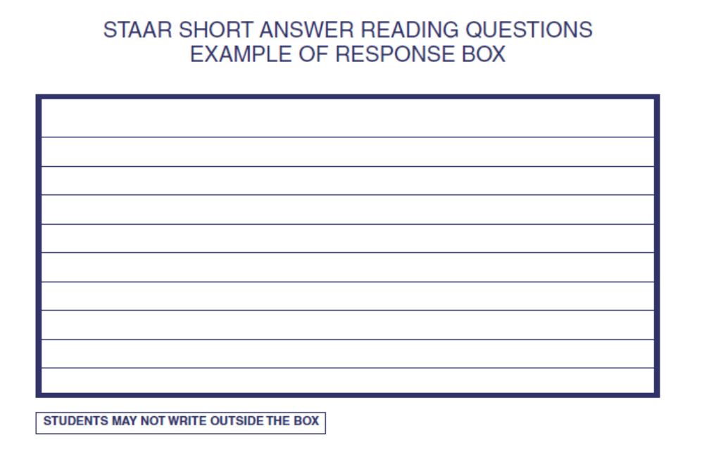
How does Argos change over the course of the story?

Selection 2:
How does Homer create interest for the reader in his introduction to The Odyssey?

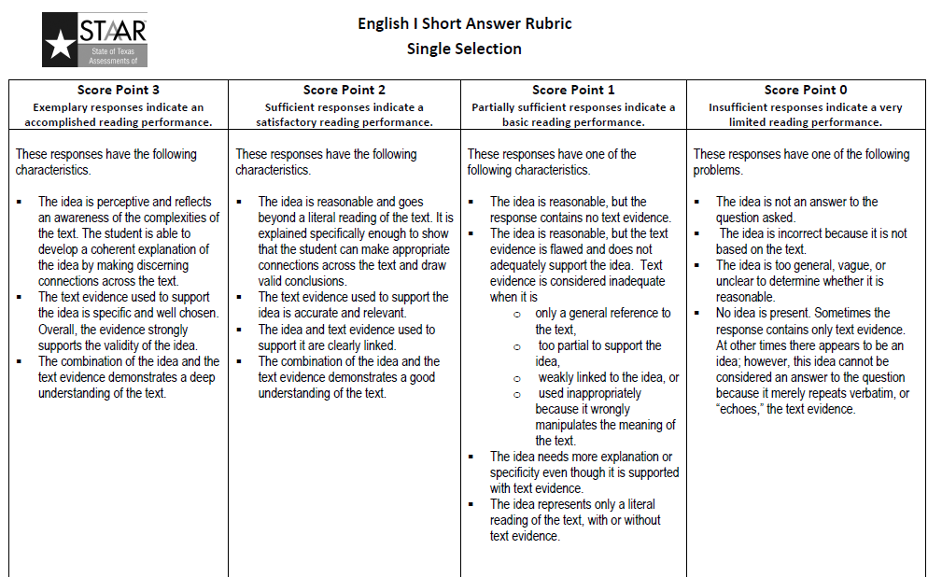

Scoring:
3 = 100
2.5 = 90
2 = 80
1.5 = 70
1 = 60

This assignment counts as a major grade. Each response will count for 50%.

