Jurassic Park Viewing Guide
For 10 points of extra credit on a quiz, annotate the Hero’s Cycle graphic with plot points from Jurassic Park.
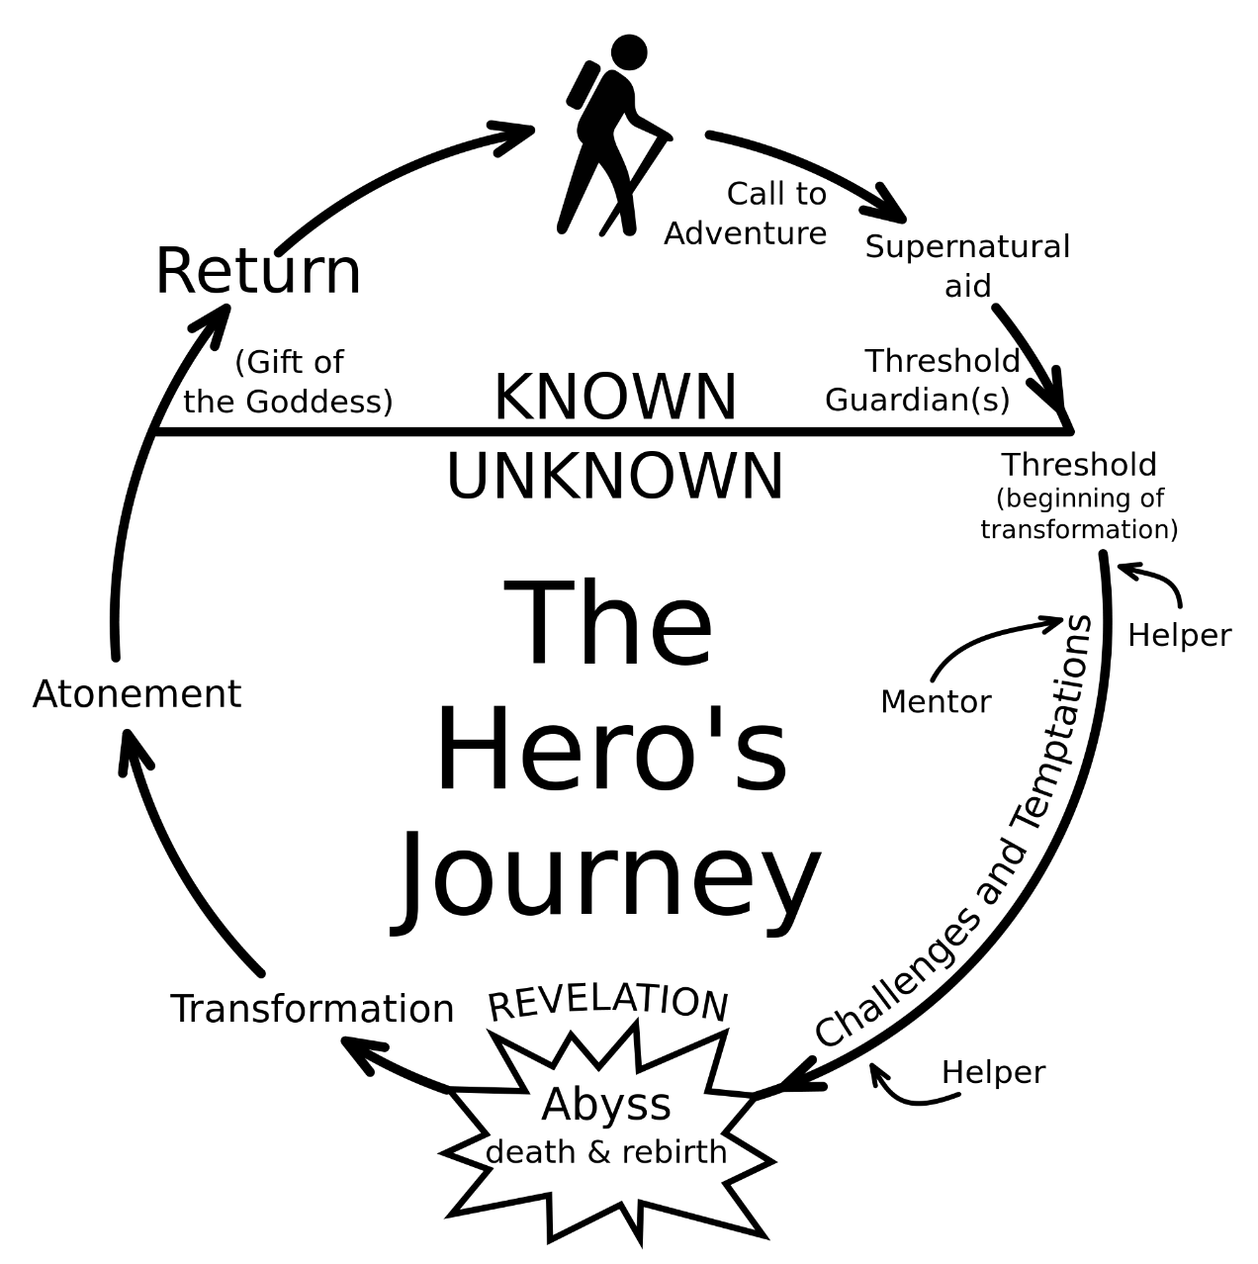

My child has viewed Jurassic Park and has completed this assignment independently. ___________________________________ / ___________________________
Parent Signature Parent Email Address

