Hero’s Journey Film Viewing Guide
For 10 points of extra credit on a quiz, watch a film that you have not seen before (your choices are The Lion King, The Wizard of Oz, The Lord of the Rings, Finding Nemo, or Batman Begins) and annotate the Hero’s Cycle graphic with plot points.
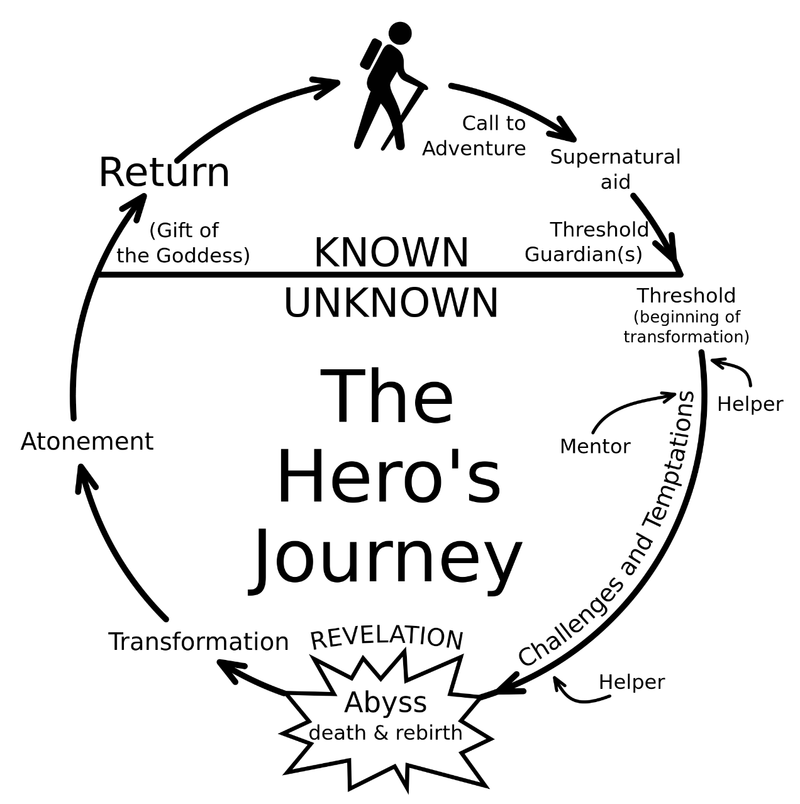

My child has viewed Jurassic Park and has completed this assignment independently. ___________________________________ / ___________________________
Parent Signature Parent Email Address

