Infinitives Notes and Practice

The Infinitive

Recognize an infinitive when you see one.
To sneeze, to smash, to cry, to shriek, to jump, to dunk, to read, to eat, to slurp—all of these are infinitives. An infinitive will almost always begin with to followed by the simple form of the verb, like this:

To + Verb = Infinitive

Infinitives can be used as nouns, adjectives, or adverbs. Look at these examples:
To sleep is the only thing Eli wants after his double shift waiting tables at the neighborhood café.
To sleep functions as a noun because it is the subject of the sentence.
No matter how fascinating the biology dissection is, Emanuel turns his head and refuses to look.
To look functions as a noun because it is the direct object for the verb refuses.
Wherever Melissa goes, she always brings a book to read in case conversation lags or she has a long wait.
To read functions as an adjective because it modifies book.
Richard braved the icy rain to throw the smelly squid eyeball stew into the apartment dumpster.
To throw functions as an adverb because it explains why Richard braved the inclement weather.

To split or not to split?

The general rule is that no word should separate the to of an infinitive from the simple form of the verb that follows. If a word does come between these two components, a split infinitive results. Look at the example that follows:
Wrong: | Sara hopes to quickly finish her chemistry homework so that she can return to the more interesting Stephen King novel she had to abandon.
Right: | Sara hopes to finish her chemistry homework quickly so that she can return to the more interesting Stephen King novel she had to abandon.
Some English teachers believe that thou shall not split infinitives was written on the stone tablets that Moses carried down from the mountain. Breaking the rule, in their eyes, is equivalent to killing, stealing, coveting another man's wife, or dishonoring one's parents. If you have this type of English teacher, then don't split infinitives!
Other folks, however, consider the split infinitive a construction, not an error. They believe that split infinitives are perfectly appropriate, especially in informal writing.
In fact, an infinitive will occasionally require splitting, sometimes for meaning and sometimes for sentence cadence. One of the most celebrated split infinitives begins every episode of Star Trek: "To boldly go where no one has gone before ...." Boldly to go? To go boldly? Neither option is as effective as the original!
When you are making the decision to split or not to split, consider your audience. If the piece of writing is very formal and you can maneuver the words to avoid splitting the infinitive, then do so. If you like the infinitive split and know that its presence will not hurt the effectiveness of your writing, leave it alone.

The Infinitive Phrase

Recognize an infinitive phrase when you see one.
An infinitive phrase will begin with an infinitive [to + simple form of the verb]. It will include objects and/or modifiers. Here are some examples:
To smash a spider
To kick the ball past the dazed goalie
To lick the grease from his shiny fingers despite the disapproving glances of his girlfriend Gloria
Infinitive phrases can function as nouns, adjectives, or adverbs. Look at these examples:
To finish her shift without spilling another pizza into a customer's lap is Michelle's only goal tonight.
To finish her shift without spilling another pizza into a customer's lap functions as a noun because it is the subject of the sentence.
Lakesha hopes to win the approval of her mother by switching her major from fine arts to pre-med.
To win the approval of her mother functions as a noun because it is the direct object for the verb hopes.
The best way to survive Dr. Peterson's boring history lectures is a sharp pencil to stab in your thigh if you catch yourself drifting off.
To survive Dr. Peterson's boring history lectures functions as an adjective because it modifies way.
Kelvin, an aspiring comic book artist, is taking Anatomy and Physiology this semester to understand the interplay of muscle and bone in the human body.
To understand the interplay of muscle and bone in the human body functions as an adverb because it explains why Kelvin is taking the class.

Punctuate an infinitive phrase correctly.
When an infinitive phrase introduces a main clause, separate the two sentence components with a comma. The pattern looks like this:
Infinitive Phrase + , + Main Clause.
Read this example:
To avoid burning another bag of popcorn, Brendan pressed his nose against the microwave door, sniffing suspiciously.
When an infinitive phrase breaks the flow of a main clause, use a comma both before and after the interrupter. The pattern looks like this:
Start of Main Clause + , + Interrupter + , + End of Main Clause.
Here is an example:
Those basketball shoes, to be perfectly honest, do not complement the suit you are planning to wear to the interview.
When an infinitive phrase concludes a main clause, you need no punctuation to connect the two sentence parts. The pattern looks like this:
Main Clause + Ø + Infinitive Phrase.
Check out this example:
Janice and her friends went to the mall to flirt with the cute guys who congregate at the food court.
Infinitives Practice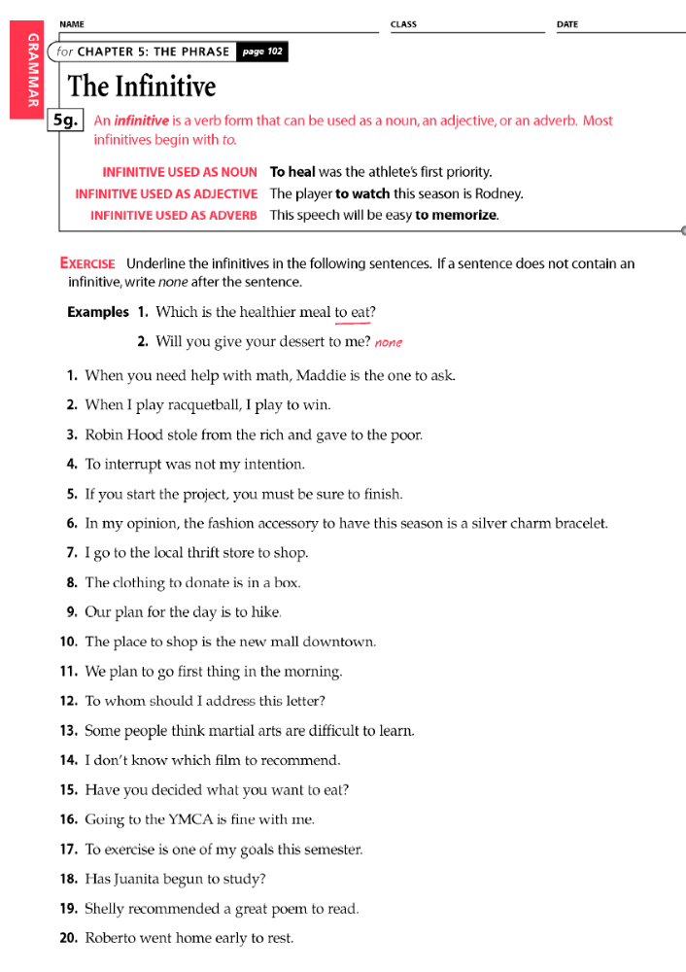
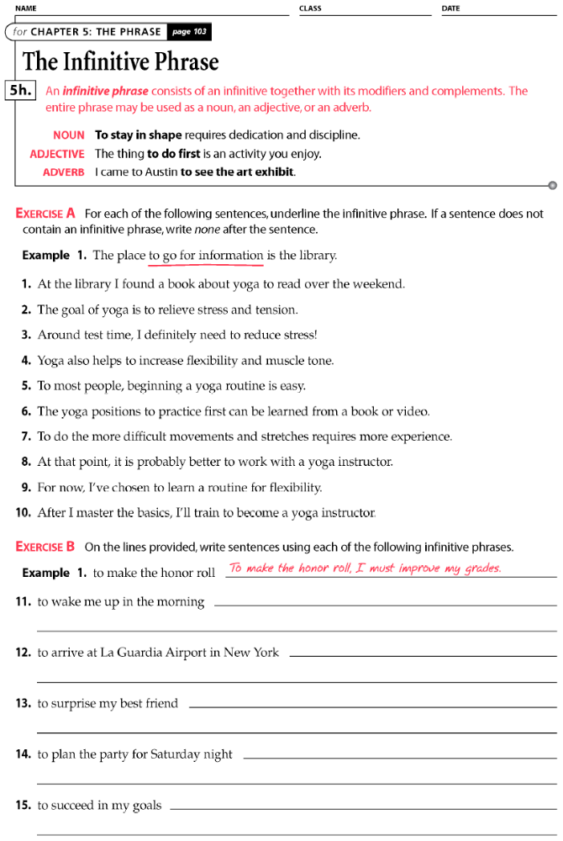

From Grammar Bytes (www.chompchomp.com)

