Gerunds Notes and Practice

The Gerund

Recognize a gerund when you see one.

Every gerund, without exception, ends in ing. Gerunds are not, however, all that easy to identify. The problem is that all present participles also end in ing. What is the difference?

Gerunds function as nouns. Thus, gerunds will be subjects, subject complements, direct objects, indirect objects, and objects of prepositions.

Present participles, on the other hand, complete progressive verbs or act as modifiers (adjectives).

Read these examples of gerunds:
Since Francisco was five years old, swimming has been his passion.
Swimming = subject of the verb has been.
Francisco's first love is swimming.
Swimming = subject complement of the verb is.
Francisco enjoys swimming more than spending time with his girlfriend Diana.
Swimming = direct object of the verb enjoys.
Francisco gives swimming all of his energy and time.
Swimming = indirect object of the verb gives.
When Francisco wore dive fins to class, everyone knew that he was devoted to swimming.
Swimming = object of the preposition to.

These ing words are examples of present participles:
One day last summer, Francisco and his coach wereswimming at Daytona Beach.
Swimming = present participle completing the past progressive verbwere swimming.
A Great White shark ate Francisco's swimming coach.
Swimming = present participle modifying coach.
Now Francisco practices his sport in safe swimming pools.
Swimming = present participle modifying pools.

The Gerund Phrase

Recognize a gerund phrase when you see one.

A gerund phrase will begin with a gerund, an ing word, and will include othermodifiers and/or objects. Gerund phrases always function as nouns, so they will be subjects, subject complements, or objects in the sentence. Read these examples:
Eating ice cream on a windy day can be a messy experience if you have long, untamed hair.
Eating ice cream on a windy day = subject of the verb can be.
A more disastrous activity for long-haired people is blowing giant bubble gum bubbles with the car windows down.
Blowing giant bubble gum bubbles with the car windows down = subject complement of the verb is.
Wild food adventures require getting your hair cut to a short, safe length.
Getting your hair cut to a short, safe length = direct object of the verb require.

Don't mistake a gerund phrase for a present participle phrase.

Gerund and present participle phrases are easy to confuse because they both begin with an ing word. The difference is that a gerund phrase will always function as a noun while a present participle phrase describes another word in the sentence. Check out these examples:
Jamming too much clothing into a washing machine will result in disaster.
Jamming too much clothing into a washing machine = gerund phrase, the subject of the verb will result.
Jamming too much clothing into the washing machine, Aamir saved $1.25 but had to tolerate the curious stares of other laundry patrons as his machine bucked and rumbled with the heavy load.
Jamming too much clothing into the washing machine = present participle phrase describing Aamir.
Bernard hates buttering toast with a fork.
Buttering toast with a fork = gerund phrase, the direct object of the verb hates.
Buttering toast with a fork, Bernard vowed that he would finally wash the week's worth of dirty dishes piled in the sink.
Buttering toast with a fork = present participle phrase describing Bernard.
My dog's most annoying habit is hogging the middle of the bed.
Hogging the middle of the bed = gerund phrase, the subject complement of the linking verb is.
Last night I had to sleep on the couch because I found my dog Floyd hogging the middle of the bed.
Hogging the middle of the bed = present participle phrase describing Floyd.

Gerunds Practice
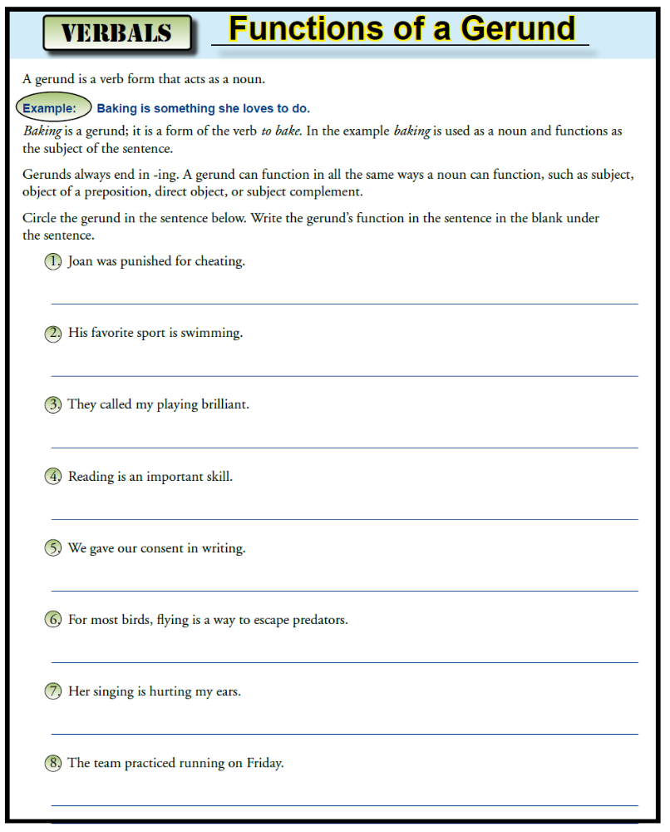

Circle the gerunds in the sentences below:

- Walking is good exercise.
- Pointing is impolite.
- I enjoy playing the flute.
- Watering the lawn produced good results.
- We avoided the rush by mailing the cards early.
- Their whispering caught the attention of the teacher.
- Shirley enjoys hiking.
- Besides swimming, what else do you like to do?
- Telling the difference between twins is hard even for their parents.
- An unforgettable experience was visiting the zoo for the first time.
- Jenny occupied herself by writing song lyrics.
- My new puppy does not like staying by itself in an empty house.

From Grammar Bytes (www.chompchomp.com)

