Ebola Political Cartoons
Directions: Below each of the political cartoons, explain what message the cartoonist is trying to communicate. Include in your response how both the words and the images contribute to that message.
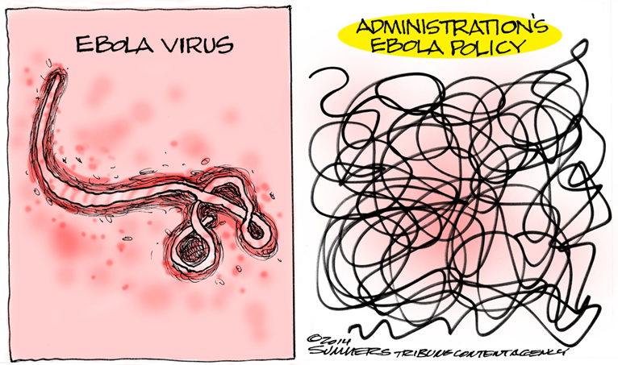
Analysis:
Analysis:
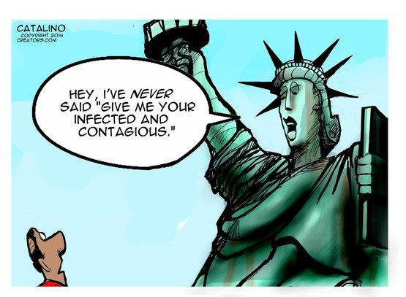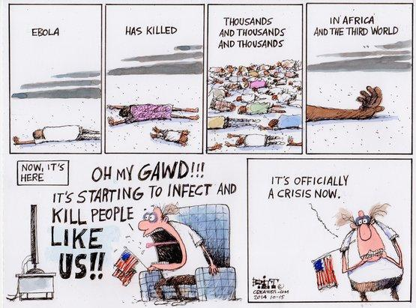
Analysis:
Analysis:

