Contagion Viewing Guide
- What points of transmission do you see within the first five minutes of the film? Pay particular attention to the points when the camera lingers.

- Make an inference as to what is in the round, black box at the 12:00 minute mark.

(Note: the 13:30 to 14:30 mark is pretty gruesome; doctors perform an autopsy of Beth Emhoff. Fast forward if you’re squeamish.)

- At the 15:20 mark, a man says to Dr. Erin Mears (Kate Winslet) that she is not dressed appropriately for the chilly weather, and that he doesn’t want her to catch a cold. What is the relationship between the temperature and transmission of infectious disease?

- What are “fomites?”

- What is the R_{0,} or r naught?

(Just FYI, here are some r naughts for major diseases.)
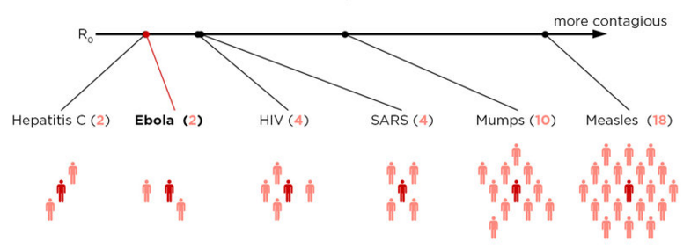
(from http://www.npr.org/sections/health-shots/2014/10/02/352983774/no-seriously-how-contagious-is-ebola)
- What parts of the Level 4 laboratory from Contagion are familiar to you because of The Hot Zone?

- What does it mean when the scientists call the new virus a “chimera?” (You might have to look up this allusion.)

- What two species of animals appear to have contributed DNA to the virus?

- Do you believe that Dr. Cheever deserved to be punished for giving his girlfriend advance notice that Chicago would be put under quarantine? Explain.

- What was the ultimate origin of the outbreak? (Hint – it’s the very last scene.) Explain how environmental degradation played a role

- Write a paragraph comparing a character who acts selfishly to a character who acts altruistically in the film.

- Explain how one of the following themes is present in the film (circle the one your select):
- Disease impacts people differently depending on their economic status.
- Bureaucracy gets in the way of effective treatment and containment.
- Uncertainty leads to fear.

