NAME: DATE: PERIOD:
Verbs
Notes:
- What kinds of jobs do verbs do?

- Explain what conjugation means.

- Explain what person means.

- Explain what number means.

- What are the rules for collective nouns and subject-verb agreement?

- What is the rule for compound subjects and subject-verb agreement?

- Explain what tense means.

- What are the different tenses, and what do they mean?

- Explain what aspect means.

- What are the different aspects, and what do they mean?

- Why is consistency of tense important?

- What is the emphatic form? How do you make it?

- What are auxiliary (helping) verbs?

- What are linking verbs?

- What are transitive and intransitive verbs?

- What are infinitives?

- What are participles?

- What makes a verb irregular?

Practice:
Conjugate the following verbs in the simple present tense.
LIVE | singular | plural |  | READ | singular | plural |  | WRITE | singular | plural
first person |  |  |  | first person |  |  |  | first person
second person |  |  |  | second person |  |  |  | second person
third person |  |  |  | third person |  |  |  | third person

Write the person and the number of the verb in each of the following examples.
The bandit robbed the people of their money. | third-person singular | I tripped on the rug.
He told his wife he loved her. |  | We need to have a talk.
You should not believe everything you read. |  | The music is exceptional.
They like to cook Indian food. |  | Pandas prefer vegetarian food.

Decide whether the underlined collective subject is in agreement with its bolded verb, then explain why.
The family are travelling to Colorado for summer vacation.
In agreement? Y/N | Why?
The team wins all of the games in the season.
In agreement? Y/N | Why?
The company makes a lot of money.
In agreement? Y/N | Why?
The audience clap after the performance.
In agreement? Y/N | Why?

Decide whether the underlined compound subject is in agreement with its bolded verb, then explain why.
A positive attitude and a strong work ethic is necessary to succeed in life.
In agreement? Y/N | Why?
Marco and DeShawn enjoy learning about astronomy in science class.
In agreement? Y/N | Why?

Conjugate the following verbs in the simple past, simple present, and simple future tenses.
TO CREATE
SIMPLE PAST |  |  |  | SIMPLE PRESENT |  |  |  | SIMPLE FUTURE
 | singular | plural |  |  | singular | plural |  |  | singular | plural
first person |  |  |  | first person |  |  |  | first person
second person |  |  |  | second person |  |  |  | second person
third person |  |  |  | third person |  |  |  | third person

TO ANALYZE
SIMPLE PAST |  |  |  | SIMPLE PRESENT |  |  |  | SIMPLE FUTURE
 | singular | plural |  |  | singular | plural |  |  | singular | plural
first person |  |  |  | first person |  |  |  | first person
second person |  |  |  | second person |  |  |  | second person
third person |  |  |  | third person |  |  |  | third person

Identify the tense in each of the following examples:
The students will do their homework tonight. | future simple | You and I will work on the project together.
Avocados provide lots of nutrients. |  | Kindness is contagious.
She plans on running for President. |  | I jumped off of the train.
What happened to the sofa? |  | You fix the computer.

Identify the tense and aspect in each of the following examples:
I am running to the store. | present continuous | You will be learning a lot in class this year.
He had worked hard on the project. |  | A meteor will cross the sky tonight.
I will have prepared your lunch by noon. |  | I believe in a thing called love.
The dog was trying to dig under the fence. |  | Shawn and Prashant have purchased tickets.

Match the description of the tense and aspect to its label. Try to figure it out without looking at your notes!
Term Bank:
past simple present simple future simple past continuous present continuous
future continuous past perfect present perfect future perfect

- ____________________ existing or happening before a specific time in the future
- ____________________ existing or happening over a period of time now
- ____________________ existing or happening before a specific time in the past
- ____________________ existing or happening now
- ____________________ existing or happening over a period of time in the past
- ____________________ existing or happening sometime before now
- ____________________ existing or happening in the future
- ____________________ existing or happening in the past
- ____________________ existing or happening over a period of time in the future

Explain the differences between the following pairs of sentences:

Flowers bloom in spring. | Flowers do bloom in spring.

Darius plays hockey. | Darius does play hockey.

You know karate? | You do know karate?

Circle all of the auxiliary verbs in the sentences below:
- We shall overcome.
- Ask not what your country can do for you, but what you can do for your country.
- Children ought to be seen and not heard.
- You must act according to your conscience.
- We are waiting for you to come down the stairs.
- Could you pass me the Grey Poupon mustard?
- It might rain this weekend.
- The student asks if she may borrow the book.
- I would love it if you could bake me a cake.
- I have studied hard for the test.

Circle all of the linking verbs in the sentences below:
- Robert is jealous that his roommate has a new girlfriend.
- In Houston, the weather stays hot through the end of October.
- When life appears hopeless, just sing a little song.
- Something in the locker smelled disgusting.
- As she was about to step out of the plane for her first skydiving trip, Reantana felt terrified.
- If you lift weights every day, your muscles will grow stronger.
- Well, well, well, it seems that your mustache is fake.
- Shawn proved a true friend when he cancelled his vacation to take me to the hospital.
- Many people say that alligator tastes chicken-y.
- You become an adult by taking responsibility for your actions.

If the bolded verb below is intransitive, put a box around it. If it is transitive, circle it and draw an arrow showing the two words the verb connects.
Examples:
I laughed so hard milk shot out of my nose. (intransitive)
Giuseppe cooked dinner for his family. (transitive; the word “cooked” transfers the action from Giuseppe to dinner)
- Bellaire 9th graders read Romeo and Juliet in English class.
- When the fire alarm rang, everyone calmly exited the building.
- The solider died in battle.
- We painted our house purple.
- Let’s agree to disagree.
- I earn $10 an hour at my job.
- Carolina enjoys swimming in the ocean.
- After working hard all day, Manny slept like a log.
- The building shook during the earthquake.
- I could dance all night long!

Circle the infinitives in the sentences below (there may be more than one in a sentence):
- To be or not to be, that is the question.
- Do you want to go to the store with me?
- You need to study in order to perform well on the test.
- I like to eat, eat, eat… apples and bananas!
- To err is human, to forgive, divine.

Subject-Verb Agreement Practice (from Sinclair College):
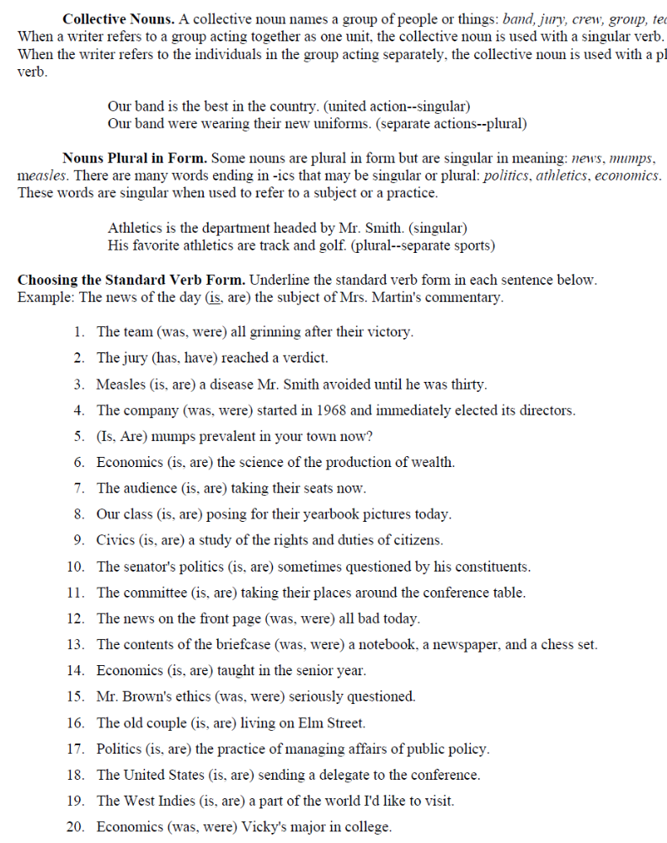

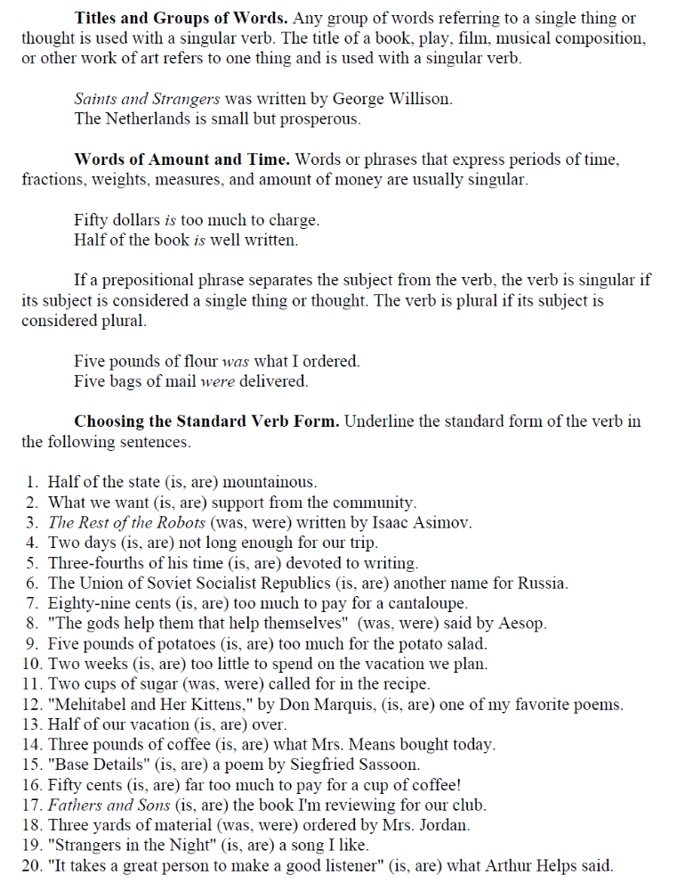

Irregular Verbs: Study the following list of irregular verbs, and then use the chart to complete the sentences on the following page.
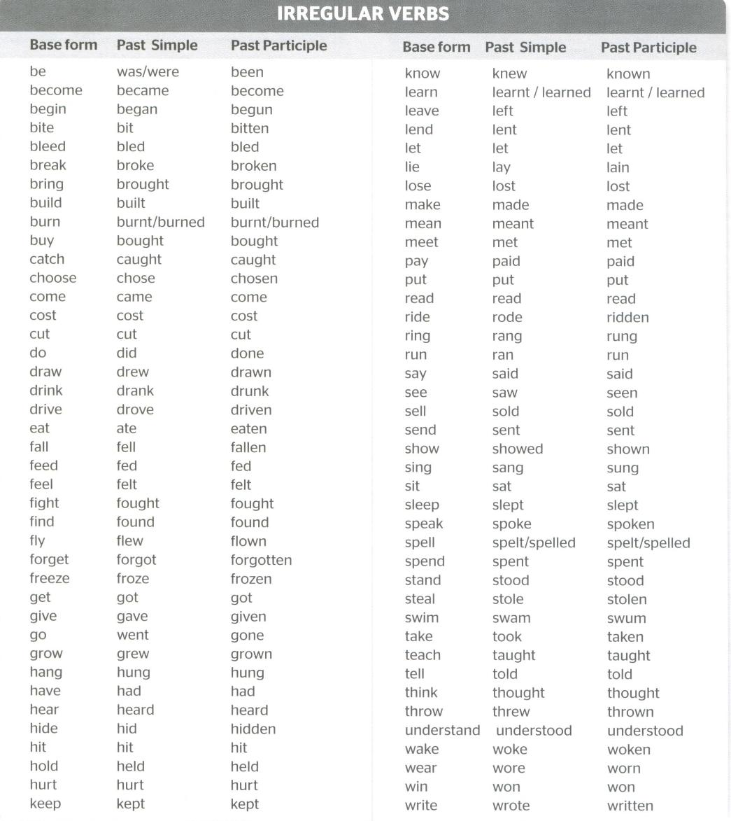

- Last night I __________ (to hear) wolves howling outside my house.
- It is a well-__________ (to know) fact that putting your hand in the garbage disposal is dangerous.
- After she found out that her car had been stolen, Marcia __________ (to become) furious.
- In the American Civil War, the North and the South __________ (to fight) against one another.
- We couldn’t discover who had _________ (to throw) the baseball into the window.
- After his mother read him a story, the boy __________ (to sleep) soundly.
- I was surprised to find out that gasoline __________ (to cost) so much.
- You __________ (to drink) all the rootbeer, so now I am sad.
- The plane had __________ (to fly) through dangerous weather to reach its destination.
- The cowboys had __________ (to ride) 30 miles before they realized half the cattle were missing.
- Yesterday Mortimer __________ (to hurt) Magdalena’s feelings.
- Kristina was upset that her brother had __________ (to forget) her birthday.
- Isaac __________ (to break) Reynaldo’s heart last year.
- I __________ (to think) you were my friend, but it turns out we are enemies!
- After we had __________ (to eat) Thanksgiving dinner, everyone wanted to sleep.
- Ellen always hated it when her brother __________ (to sing) in the shower because it __________ (to wake) her up.
- Susan __________ (to lend) her favorite jacket to Monica, but Monica didn’t return it.
- Once you have __________ (to grow) up, you can stay up as late as you want.
- All of this arguing has __________ (to drive) me crazy!
- Back in 8th grade, Marco __________ (to take) Algebra.

Now write 10 of your own sentences using the irregular forms of verbs (underline the verb):
1)
2)
3)
4)
5)
6)
7)
8)
9)
10)

