Webcomic Homework Assignment
Go online and find a webcomic that makes you laugh. (Make sure that it’s school-appropriate. It should also be able to stand alone – that is, the reader should be able to understand it without having to read other portions.) If you’re not sure of where to look, do a general Google search for webcomics and you should get lots of lists of some of the best. Enlarge, print out, and trim your webcomic (cut it out along the border). If possible, please try to print it in color! On the back, write a paragraph explaining how the images work to create a funny situation. (Hint – treat the images as you have done text evidence/quotations from SARs.)

For example…

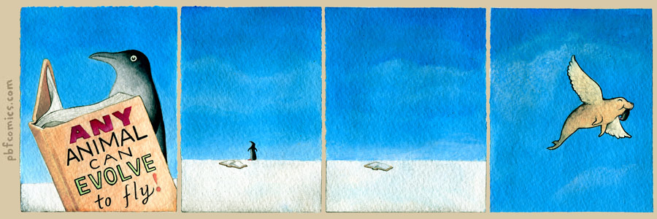

In this comic from The Perry Bible Fellowship, the first panel opens with a close-up of a penguin reading a self-help book entitled “Any Animal Can Evolve to Fly!” The penguin, which is sort of a ridiculous-looking animal, seems very serious as he reads (which is a kind of absurdity in and of itself) – the reader can imagine that he is on the brink of fulfilling a life-long dream that he never thought possible. The next two panels zoom out and show first the penguin’s silhouette along the horizon, the book behind him as he gazes up into the bright blue sky, and then the book by itself. The reader is led to imagine the penguin soaring off and enjoying his new freedom. However, in the last and final panel, the reader sees not a penguin but a seal with wings. The seal has a chubby, self-satisfied smile, and what appear to be penguin feet hanging out of his mouth. A story that the reader expected to end sweetly instead has a very dark conclusion.

