Definition of Genres and Elements of the Multigenre Essay

Letter to the Reader
What it is:
This is the entryway to your multigenre project. You must include what readers need to know about your research subject up front, but don’t tell them everything. Give your readers enough to be able to read with purpose. Make it high interest in order to instill your readers with a hunger to know more about your topic. Think of it as a prologue, an introduction, or a preface. It’s an opportunity to set the tone of your project and establish your thematic unifying elements.
Recommended Model Text:
Page 1 of “Blood and Bravery: A Multigenre on Dracula.”

Unifying Elements
What they are:
The unifying elements are the connective tissue that will hold your project together. You can create this cohesiveness across your genres using a variety of different strategies. You will be required to add a “Notes Page” at the end of your project that explains the significance of each of your unifying elements.
You can:
1. Repeat an image, a detail, or exact language. In other words, you can use your many genres to craft a symbol or resonate a theme. For example, if you chose to do your paper on Emily Dickinson, you might decide to repeat the image of a door to emphasize her isolation. If you chose to do your project on Antione Lavoisier, you could explore the meanings of one of his many awesome quotes, such as, “Nothing is created either in the operations of art or those of nature; and it may be considered as a general principle that in every operation there exists an equal quantity of matter before and after the operation.”
2. Repeat a pattern of quotations, pictures or titles. For example, if you chose to do your research project on Marshall Mathers, you could weave lyrics from his songs throughout the project. If you chose to do your project on Marie Curie, you could punctuate your project with repeated x-ray images. If you chose to do your project on Chopin, you could adopt and reimagine some of the titles of his compositions as titles of the components of your paper.
Recommended Model Text:
Page 23 of “Blood and Bravery: A Multigenre on Dracula.”
Reworked Expository Piece
What it is:
This is your documented essay, revised as the keystone piece of your mulitgenre project. Focus your revision on crafting the unifying elements that will echo off the other elements of your project. Use other teacher and classmate feedback to help polish and tighten this second draft of your essay.
Recommended Model Text:
Mrs. Newton’s “Antione Lavoisier: Creator of Thought Structures”

Poetry
You will now create one poem from one of the categories below which will provide insight into the life of your hero, times in which they lived, a symbolic reflection of your hero, or the inner thoughts of your hero. Your poem will follow the rules and style of one of the following sub-genres:
Option 1: Epic Poem
What it is:

An epic poem is a poem which contains the following elements:

- It is a long narrative about a serious or worthy traditional subject.
-Its diction is elevated in style. It employs a formal, dignified, objective tone and many figures of speech.
- The action takes place in a vast setting; it covers a wide geographic area.
- The action contains superhuman feats of strength, intelligence, or military prowess.
- The poem begins with the invocation of a muse to inspire the poet--i.e., a
- The narrative starts in medias res, in the middle of the action.
- The epic employs extended similes (called epic similes) at appropriate spots of the story

Your epic poem must contain a majority of these elements, be divided into stanzas, and be no shorter than 30 lines, yet no longer than 50 lines.
Recommended Model Text:
“The Song of Hiawatha,” by Henry Wadsworth Longfellow
Option 2: Prose Poem
What it is:
Prose poetry is writing that has the conventions of prose, and the compressed meaning of poetry. Mary Oliver describes it in this way:

What you see on the page is a fairly short block of type- a paragraph or two, rarely more than a page. It looks like prose. Perhaps it has characters, perhaps not. Often, it is pure description. It usually does have the same sense of difference from worldly or sequential time that one feels in a poem. And it does certainly ask to be read with the same concentration, and allowance for the fanciful and the experimental, that we give to the poem.
Recommended Model Texts:
“The World Doesn’t End” by Charles Simic. “Rural Route One,” excerpt from Trespasses from Lacy Johnson.
Option 3: Narrative Poem
What it is:
Narrative poetry is a form of poetry that tells a story, often making use of the voices of a narrator and characters as well. The entire story is usually written in verse. The poems that make up this genre may be short or long, and the story it relates to may be complex.

Recommended Model Texts: “Annabel Lee” by Edgar Allan Poe

Image
You will now create or synthesize visuals to create an image which speaks to the work or impact of your hero. Your image will follow the rules and style of one of the following sub-genres:
Option 1: Drawing
What it is:
A thoughtfully crafted drawing or painting that emphasizes your unifying elements and enriches the meaning of your project.
Recommended Model Texts:
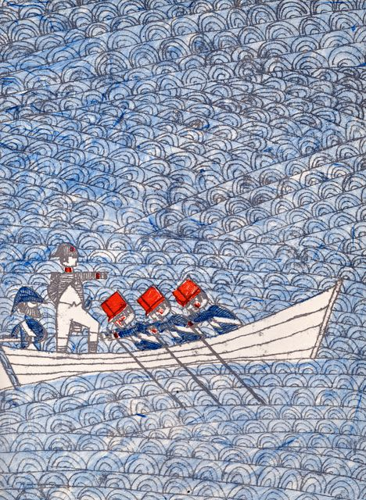

Option 2: Collage
What it is:
A collage is a piece of art made by sticking various different materials such as photographs and pieces of paper or fabric onto a backing. You can incorporate a variety of art techniques, such as painting or drawing, and you can also incorporate images and text. Your collage should emphasize your theme in some way.
Recommended Model Texts:
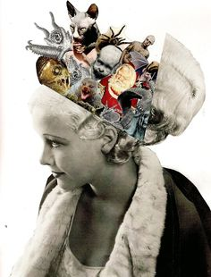

If you go to pinterest.com and search for “collage,” you will also find a bunch of ideas for using image to create meaning.
Option 3: Comic
What it is:
A comic is a visual story told with static images (not animation), and often text. Comics usually incorporate an element of surprise or humor.
If you select a comic, your product must take up at least 2/3 of the page and include at least three panels with images and text. You must attempt to make your comic funny. Images can be hand drawn or computer generated, and text must be legible.
Recommended Model Text: www.theoatmeal.com; www.hyperboleandahalf.com
Option 4: Graphic Design
What it is: An image or images that are digitally generated or altered using Photoshop, SumoPaint, or another piece of graphic design software. Graphic design is often used for advertisements and public service announcements. Graphic designers frequently use image modification to invite their readers to think differently about a subject or issue.
Recommended Model Text: http://www.creativebloq.com/inspiration/print-ads-1233780

Prose
After carefully considering the life of your subject, you create prose which will express a deep familiarity of the humanity and experiences of your selected hero. You will craft two pieces of prose which will follow the rules and style of one of the following sub-genres:
Option 1: Myth
What it is:

A myth is a story in which a hero is presented as an exaggerated or idealized concept of him or herself.

Select an event from the life of your hero and mythologize it. Remember, myths are stories so be sure that your myth has a clear conflict and resolution. You may use hyperbole, include intervention from a god or a god-like human, etc.

Recommended Model Texts:

“A Gift From Saint Nicholas,” retold by S. E. Scholsser. “Golem,” by David Wisniewski.

Option 2: Newspaper Article

What it is:

An article is a written composition in prose, usually nonfiction, on a specific topic, forming an independent part of newspaper. The formatting/conventions of an article requires the following elements:

- A headline
- A by-line
- Quotes spoken by an expert or an eye-witness
- A conclusive statement which summarizes or definitively explains the significance of the article

Select a head-line worthy moment of your subject’s life and create an informative article which explains some of the essential elements of the event (who was there, when did it occur, what was accomplished/what was the reaction of those who spectated, where did it occur, and why is this event significant.) The tone of your article should be professional as well as informative.

Recommended Model Text:
“The Privacy Debate,” page 688-690 in the Literature text book. Also check out NYTimes.com.
Option 3: Script
What it is:

A script is the written text of a play, movie, or broadcast.

The formatting/conventions of a script requires the following elements:

An opening scene description typed in italics. This description should inform the reader of the time and place of the scene as well as which characters will be introduced in the scene. The author should also include any pertinent information which will allow the scene to make sense to the reader.
- Character names preceding their dialogue
- Character directions, such as descriptions of their facial expressions or tone of voice should be written in parenthesis.
- Stage directions which explain when a character moves should be written under the dialogue in a separate line.

Select a moment in your hero’s life which would be interesting to dramatize. This scene should provide insight into your hero’s character as well as highlight their tone and diction. The scene should solve a problem, provide insight into a personal relationship, explain the hero’s fears, joys, concerns, etc, or explain a key moment in the hero’s life.

Recommended Model Text: Scene 1 from Mozart and Salieri by Alexander Pushkin

Option 4: Third-Person Narrative Scene

What it is:

A narrative scene is a story that takes in one short scene, like a one-act play. Take an interesting scene from the life of your research subject, and craft it into a narrative in the 3rd person. Remember to use dialogue to develop your characters.

Recommended Model Text: “A Clean, Well-Lighted Place” by Ernest Hemingway
Option 5: First-Person Memoir
What it is:

A narrative scene is a story that takes in one short scene, like a one-act play. Take an interesting scene from the life of your research subject, and craft it into a narrative in the 1st person. You will need to imagine the voice of your character, and you will need to maintain this voice throughout the piece.

Recommended Model Text: Pages 3-5 of The Glass Castle by Jeannette Walls

