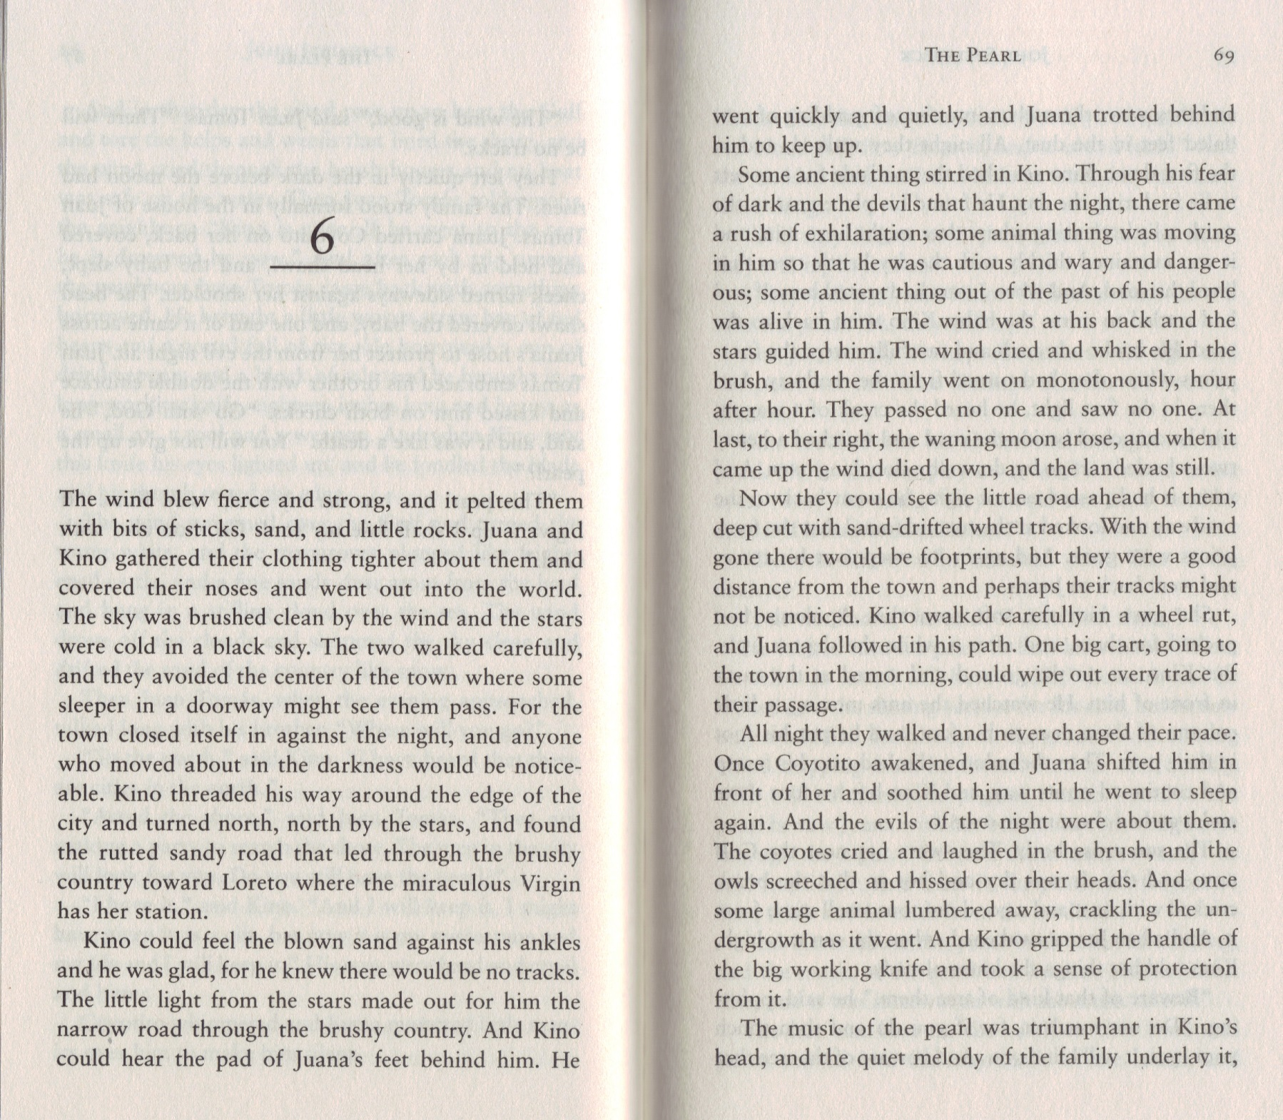

Beautiful!

The Virgin de Guadalupe, or Mary, the mother of Jesus Christ.

Theme: Colonialism and Oppression
WHAT IS HAPPENING TO KINO?

Theme: Music

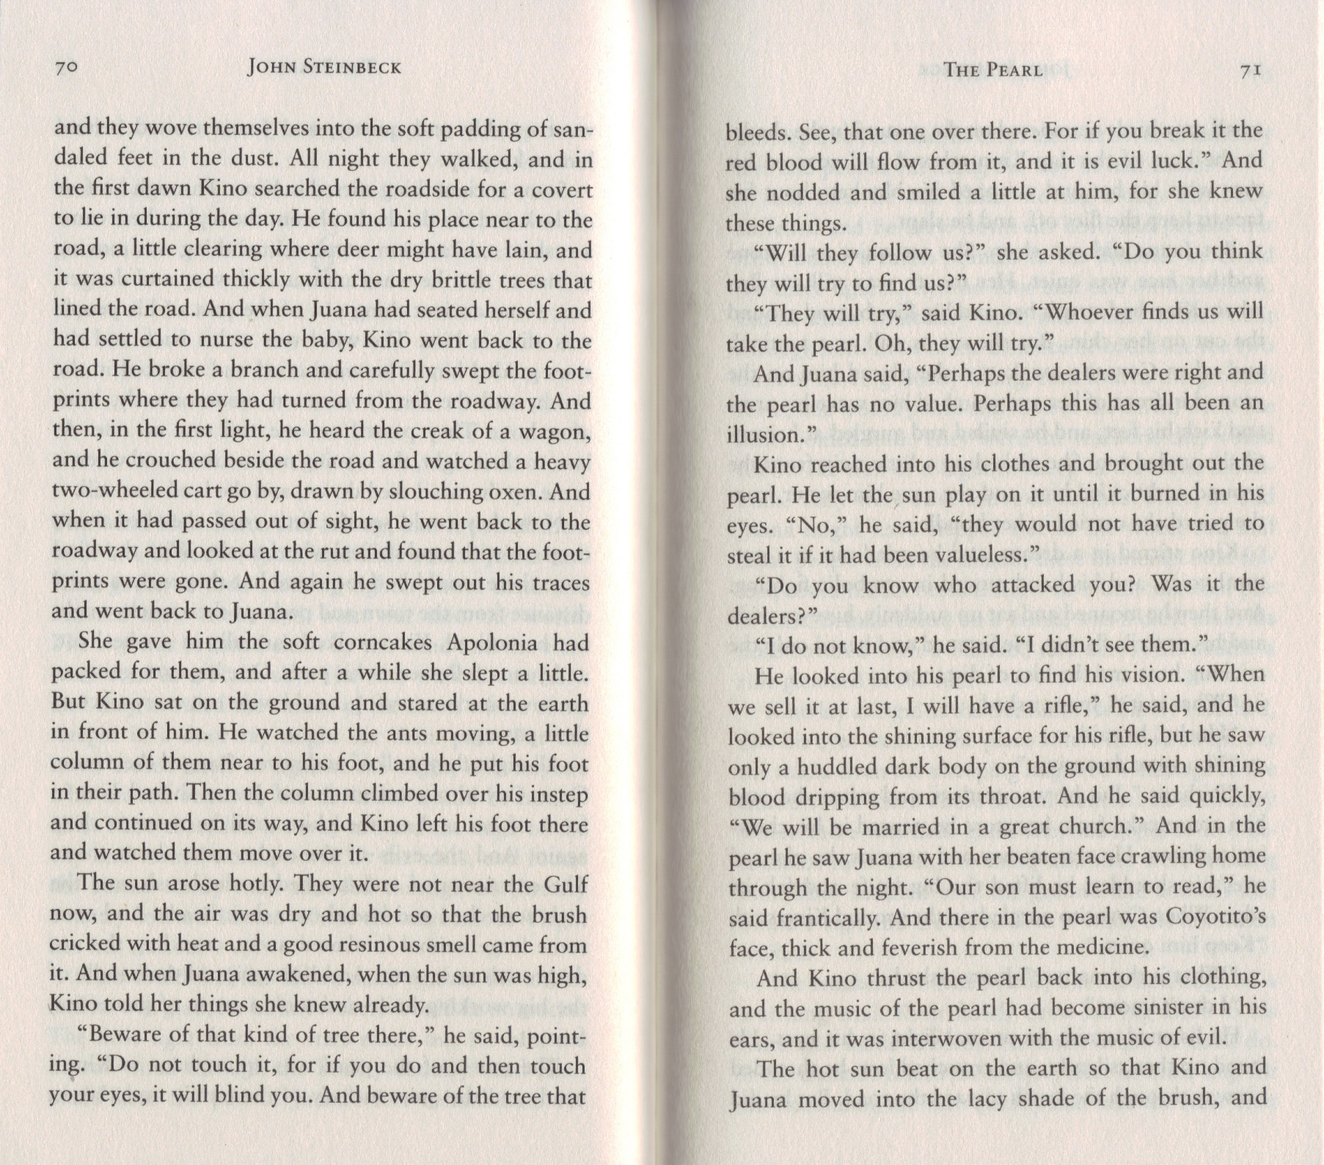

REMEMBER THE WAY THAT KINO WATCHED THE ANTS BEING EATEN BY THE ANT LION IN CHAPTER 1. WHY DOES THE AUTHOR RETURN TO THIS IMAGE? (HINT – HOW COULD IS BE A METAPHOR?)

WHY IS KINO TELLING HER THINGS SHE ALREADY KNOWS?

Theme: Greed and Corruption

Theme: Colonialism and Oppression

Theme: Music
DRAW WHAT THE LACY SHADE OF THE BRUSH LOOKS LIKE.

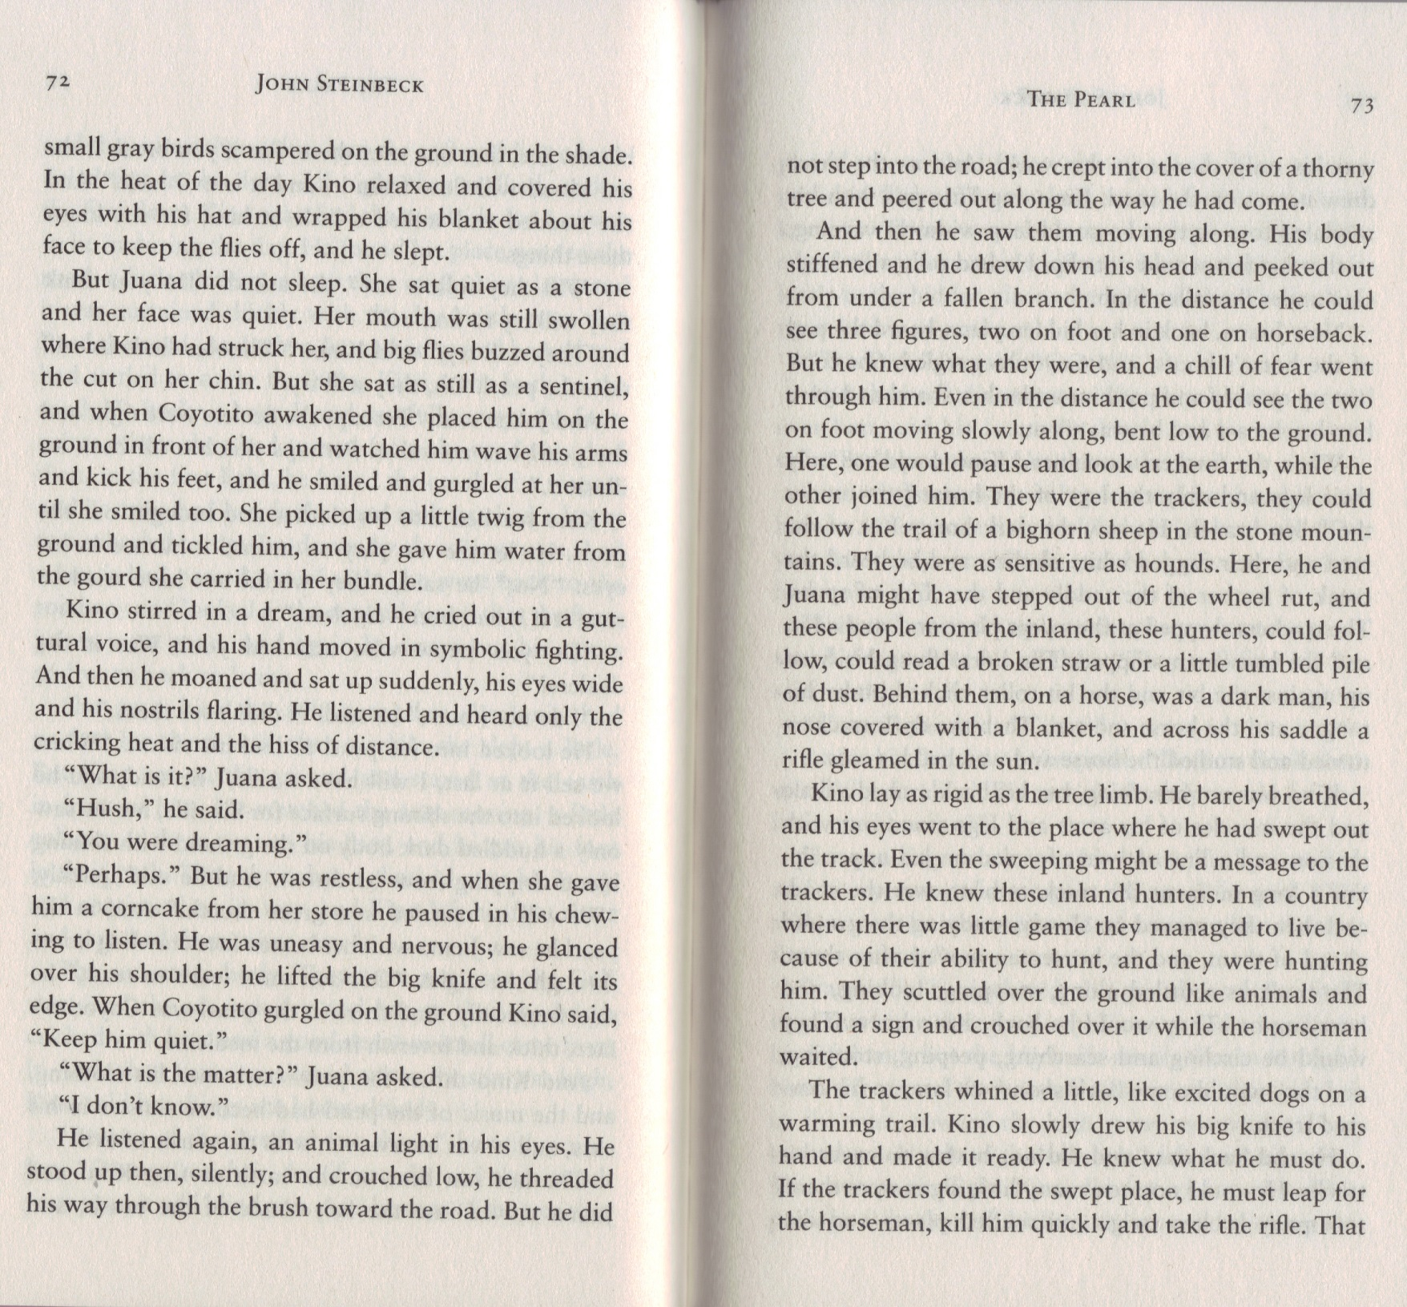

DESCRIBE A TIME WHEN YOU FELT A CHILL OF FEAR:

WHAT DOES THE AUTHOR WANT US TO UNDERSTAND BY DESCRIBING BOTH KINO AND THE HUNTERS AS ANIMALS?
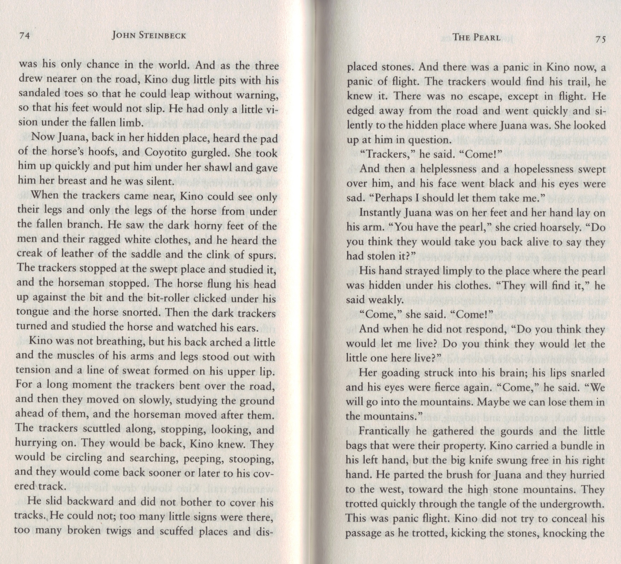

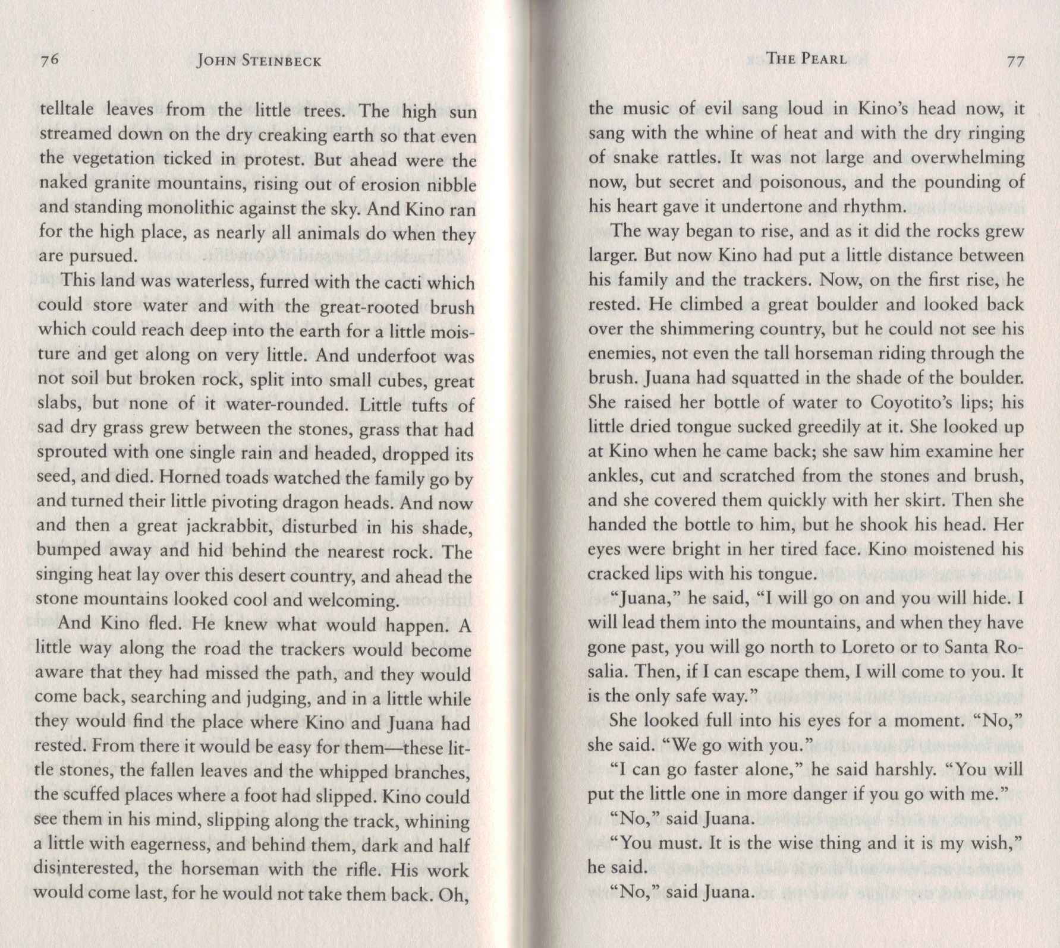

Remember how Kino shouted at Juana that he was a man?

DRAW A PICTURE OF WHAT THIS LANDSCAPE LOOKS LIKE.

Theme: Music

WHY DOESN”T KINO DRINK ANY WATER?

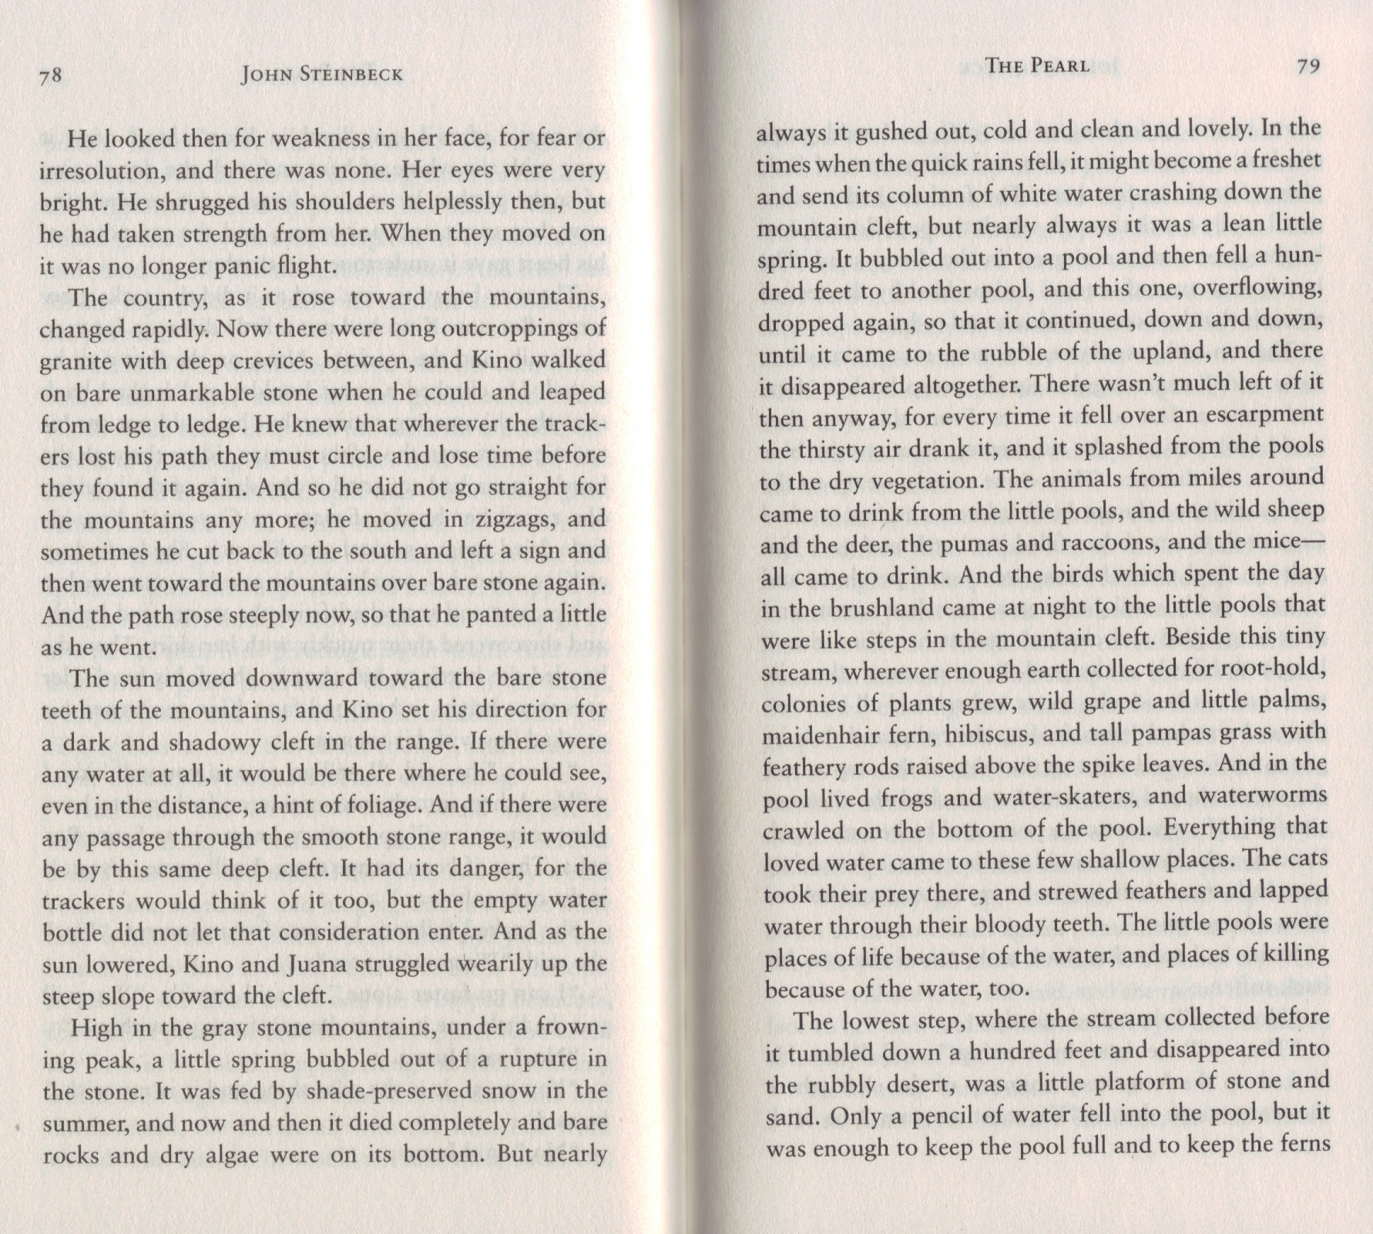

EXPLAIN WHY KINO IS NOT TAKING A STRAIGHT PATH:

Beautiful!

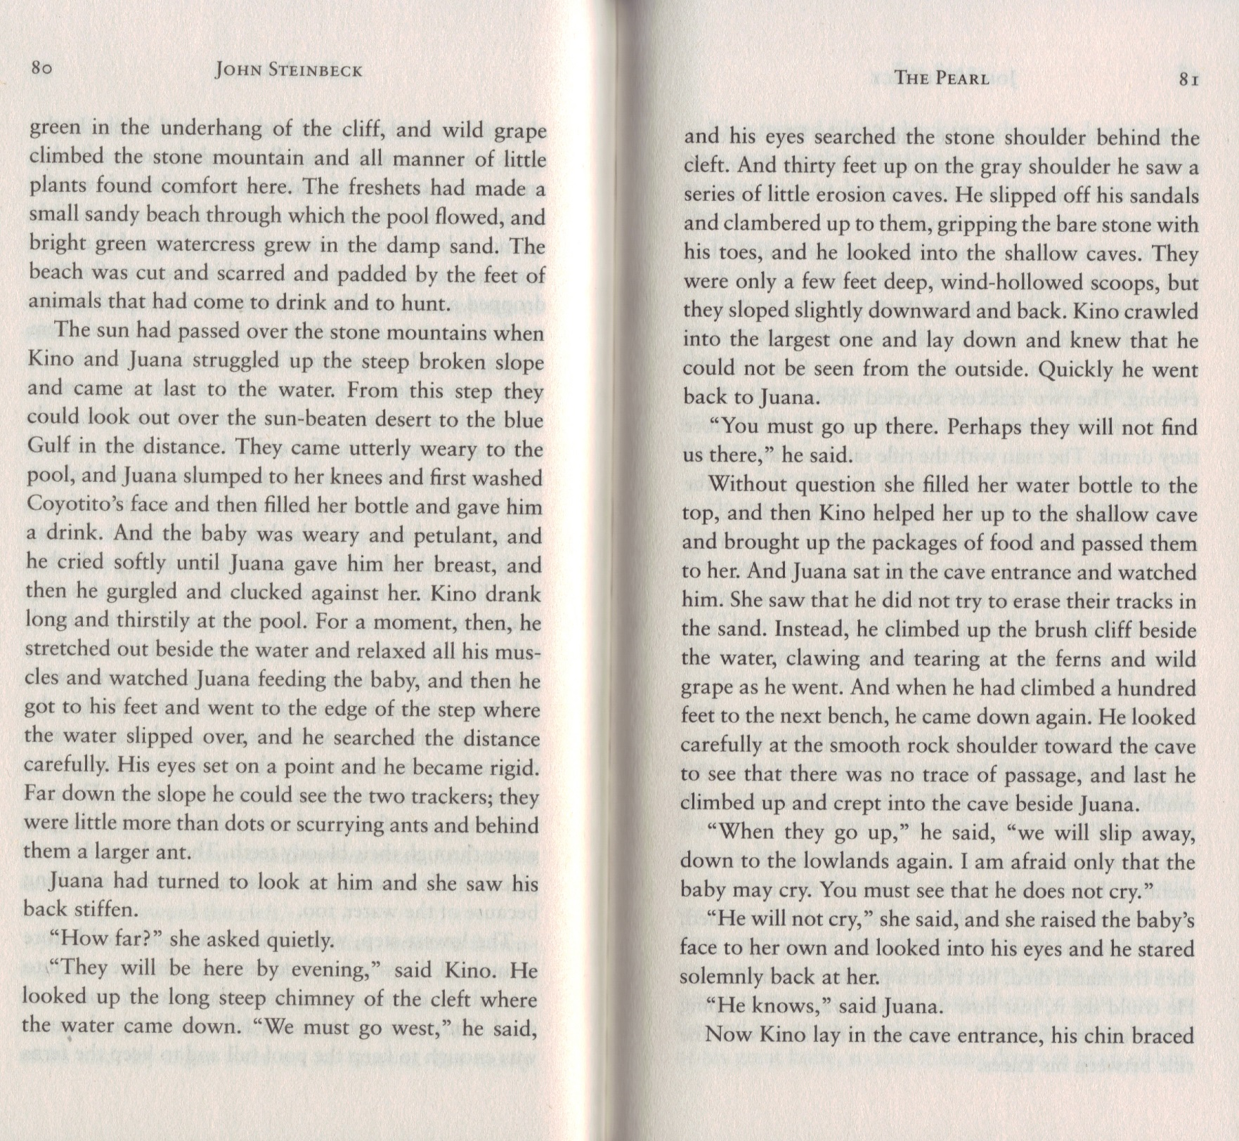

HOW MIGHT THIS BE A METAPHOR FOR ONE OF THE THEMES OF THE STORY?

DRAW WHAT THIS LOOKS LIKE:
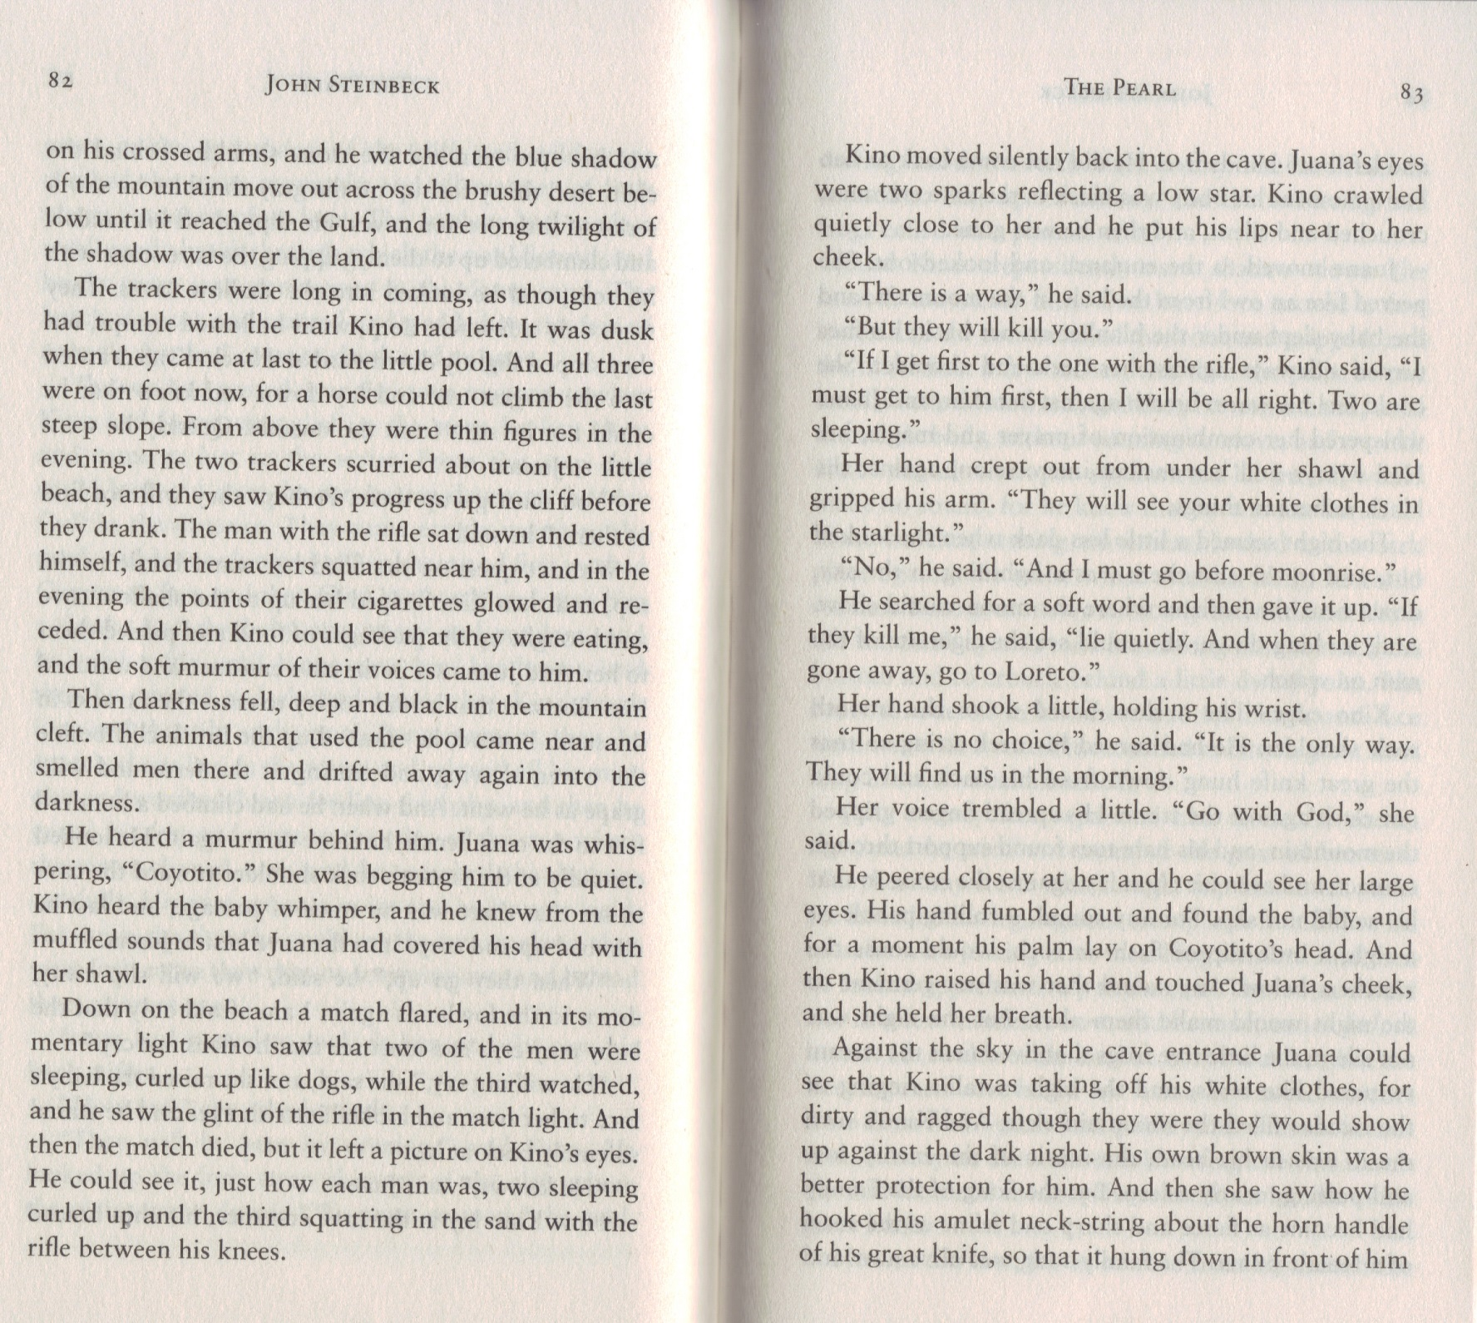

The author describes the men as animals.

Beautiful!

WHAT ELSE IS WHITE AND SORT OF GLOWING IN THE STORY?

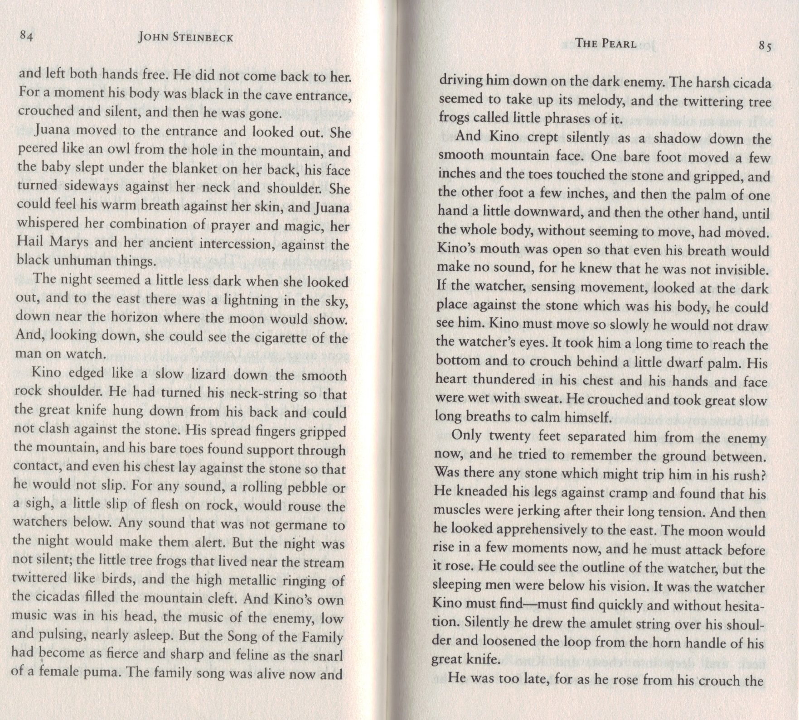

Theme: Colonialism and Oppression

Again, Kino is described as an animal.

Theme: Music

A puma is a cougar.

OTHER THAN THE MOON, IS THERE ANOTHER LARGE, ROUND, WHITE, SEMI-SHINY OBJECT IN THIS STORY?

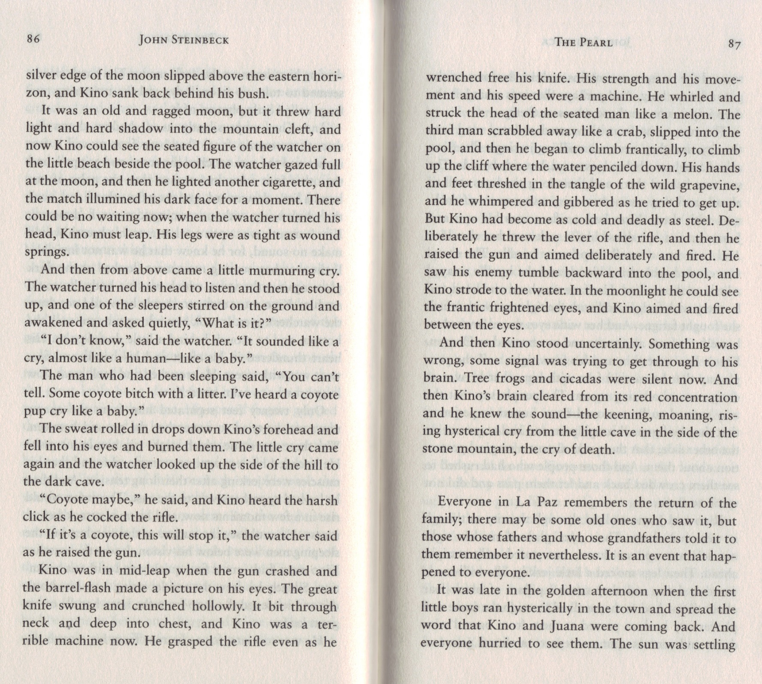

WHO IS CRYING?

Again with the animals.

Another comparison of a person to an animal.

WHAT DO YOU THINK HAS HAPPENED?

Who’s not coming back with them?

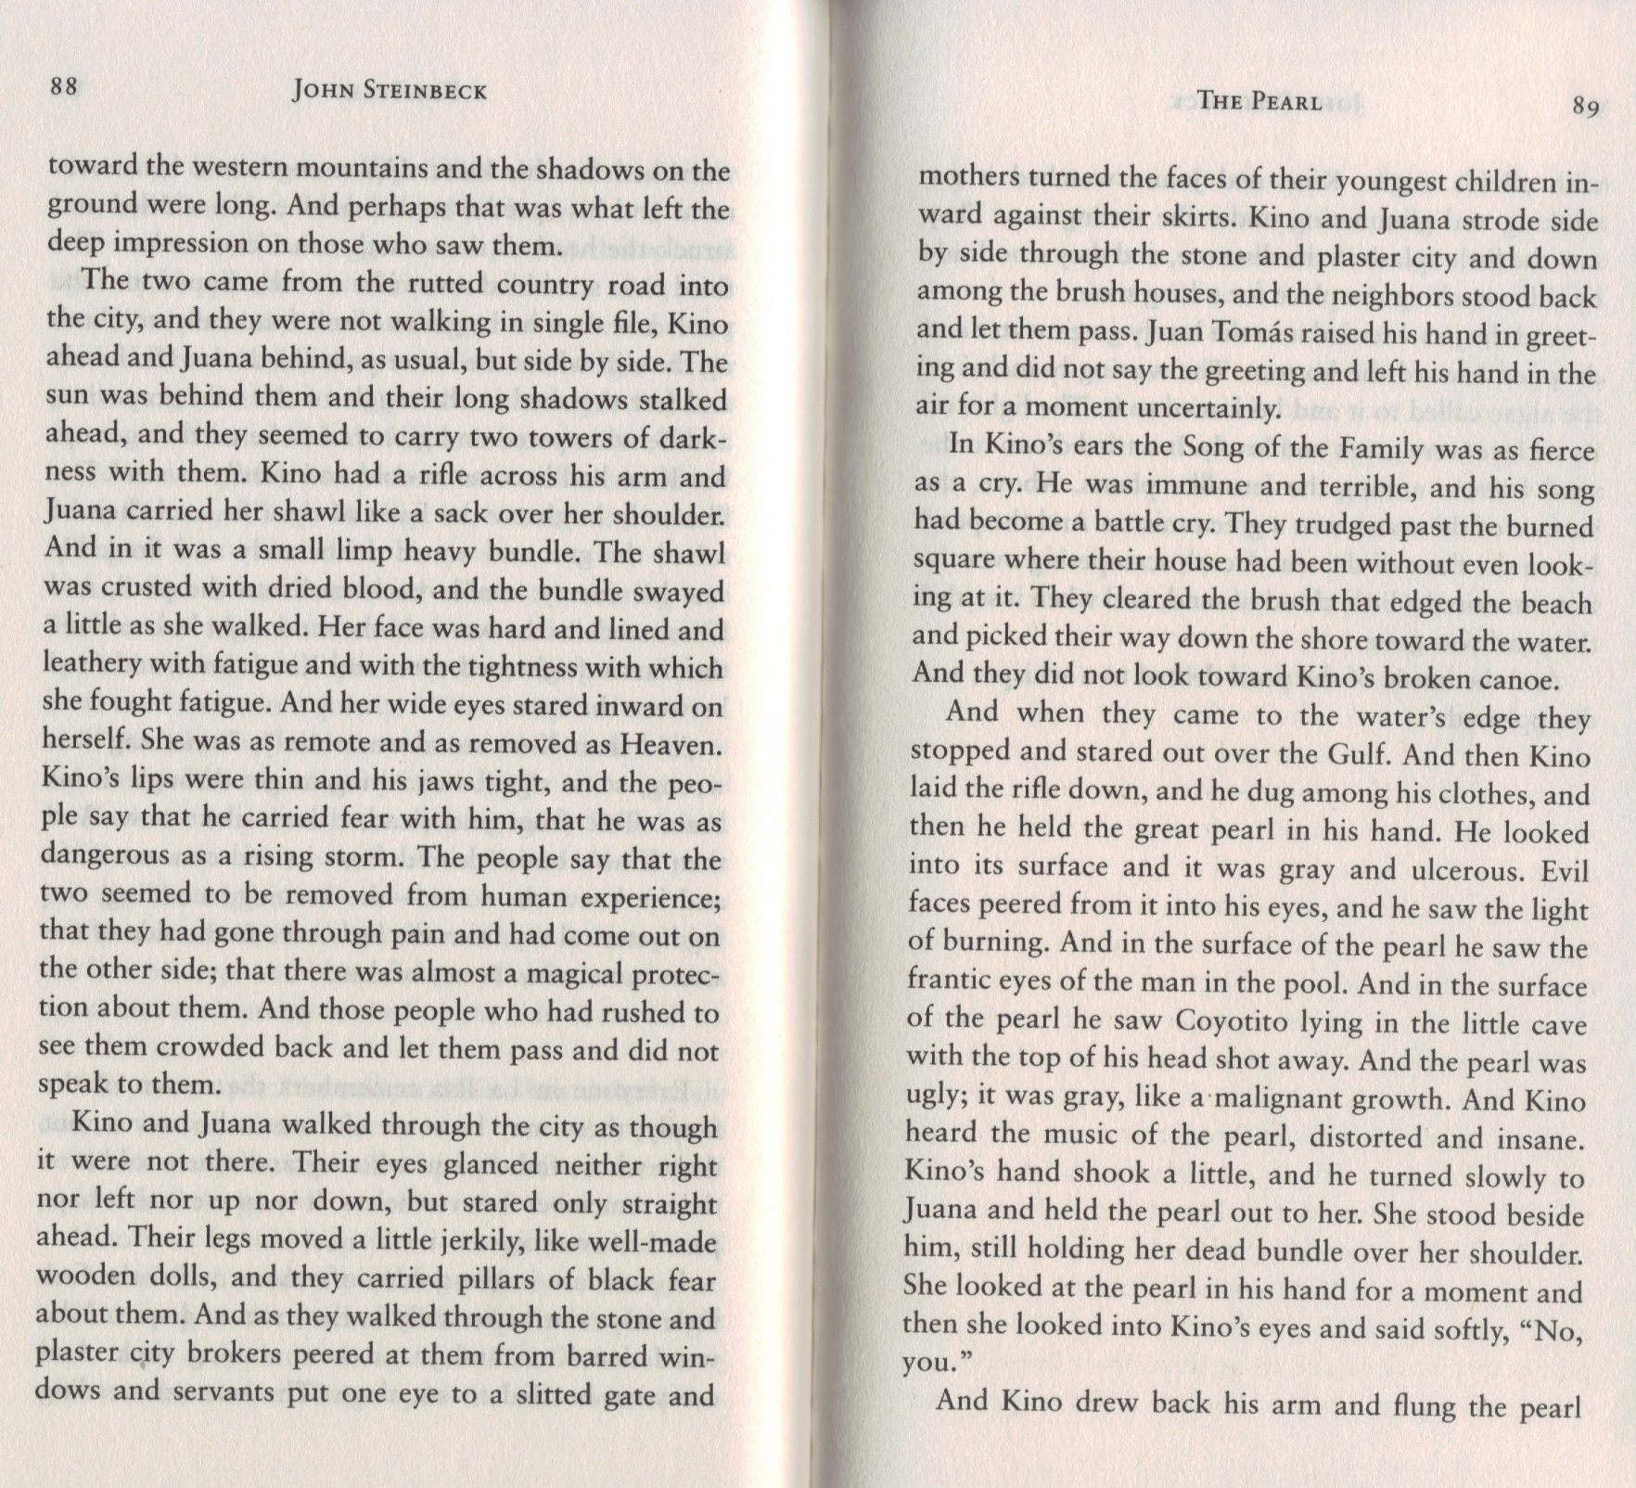

WHY ARE THEY WALKING SIDE BY SIDE?

WHAT DO YOU THINK IS INSIDE THE BUNDLE?

Theme: Music

!!!!!!!!!!!!

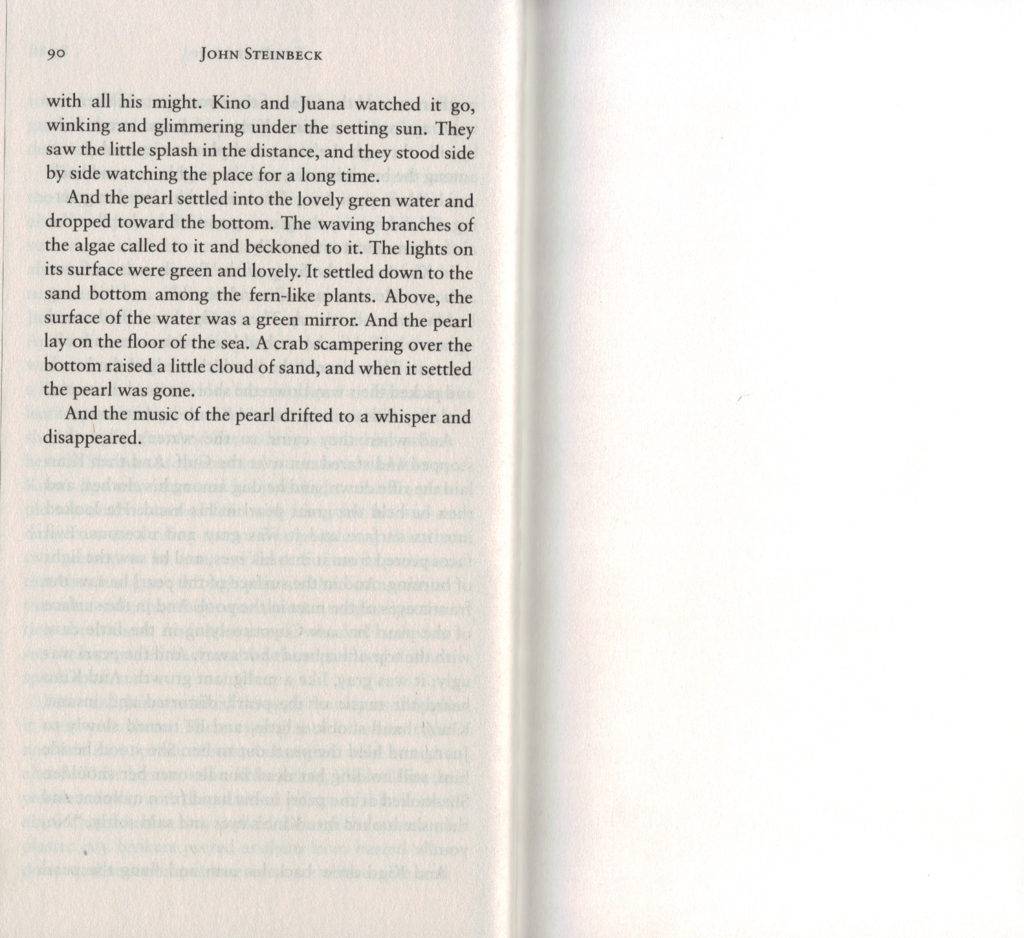

DRAW WHAT THIS LOOKS LIKE:

HOW DO YOU FEEL AT THE END OF THIS STORY?

