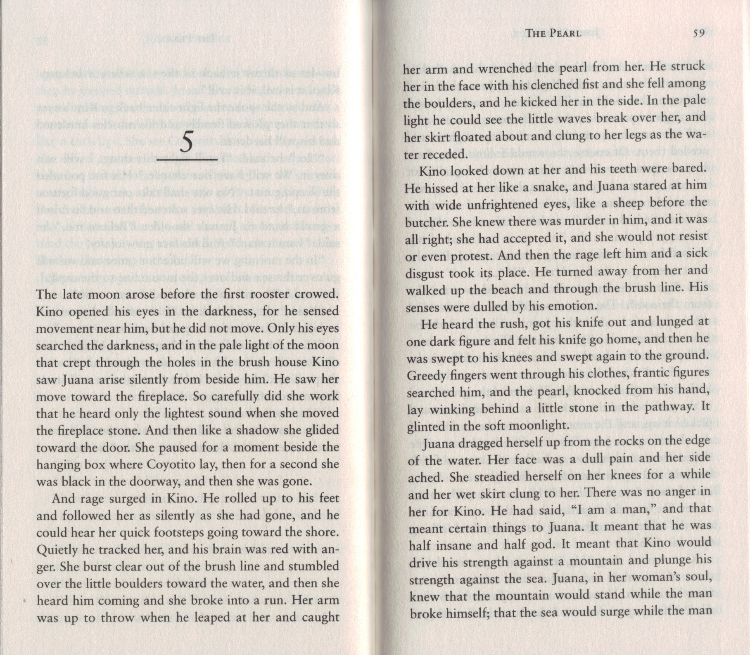
DRAW A PICTURE OF THE SCENE DESCRIBED IN THE FIRST PARAGRAPH.

WHY IS KINO ANGRY WITH JUANA?

HOW IS KINO CHANGING FROM THE PERSON HE WAS AT THE START OF THE STORY?

WHEN THE AUTHOR COMPARES JUANA TO A SHEEP, TO WHAT MIGHT HE BE MAKING AN ALLUSION? (HINT – IT’S IN THE BIBLE.)

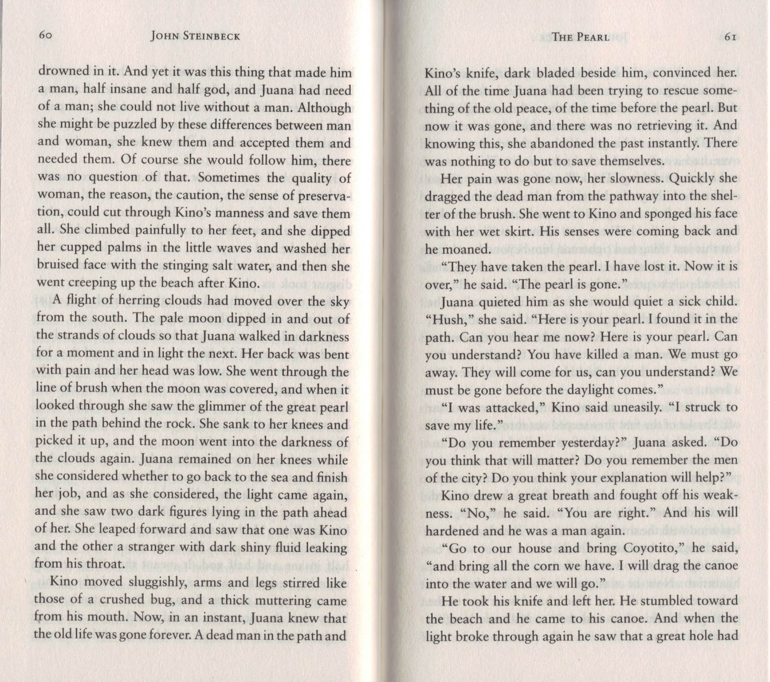

WHAT MIGHT THE DARK SHINY FLUID LEAKING FROM HIS THROAT BE?

WHY DOES JUANA GIVE HIM THE PEARL BACK?

WHY ARE THEY LEAVING?

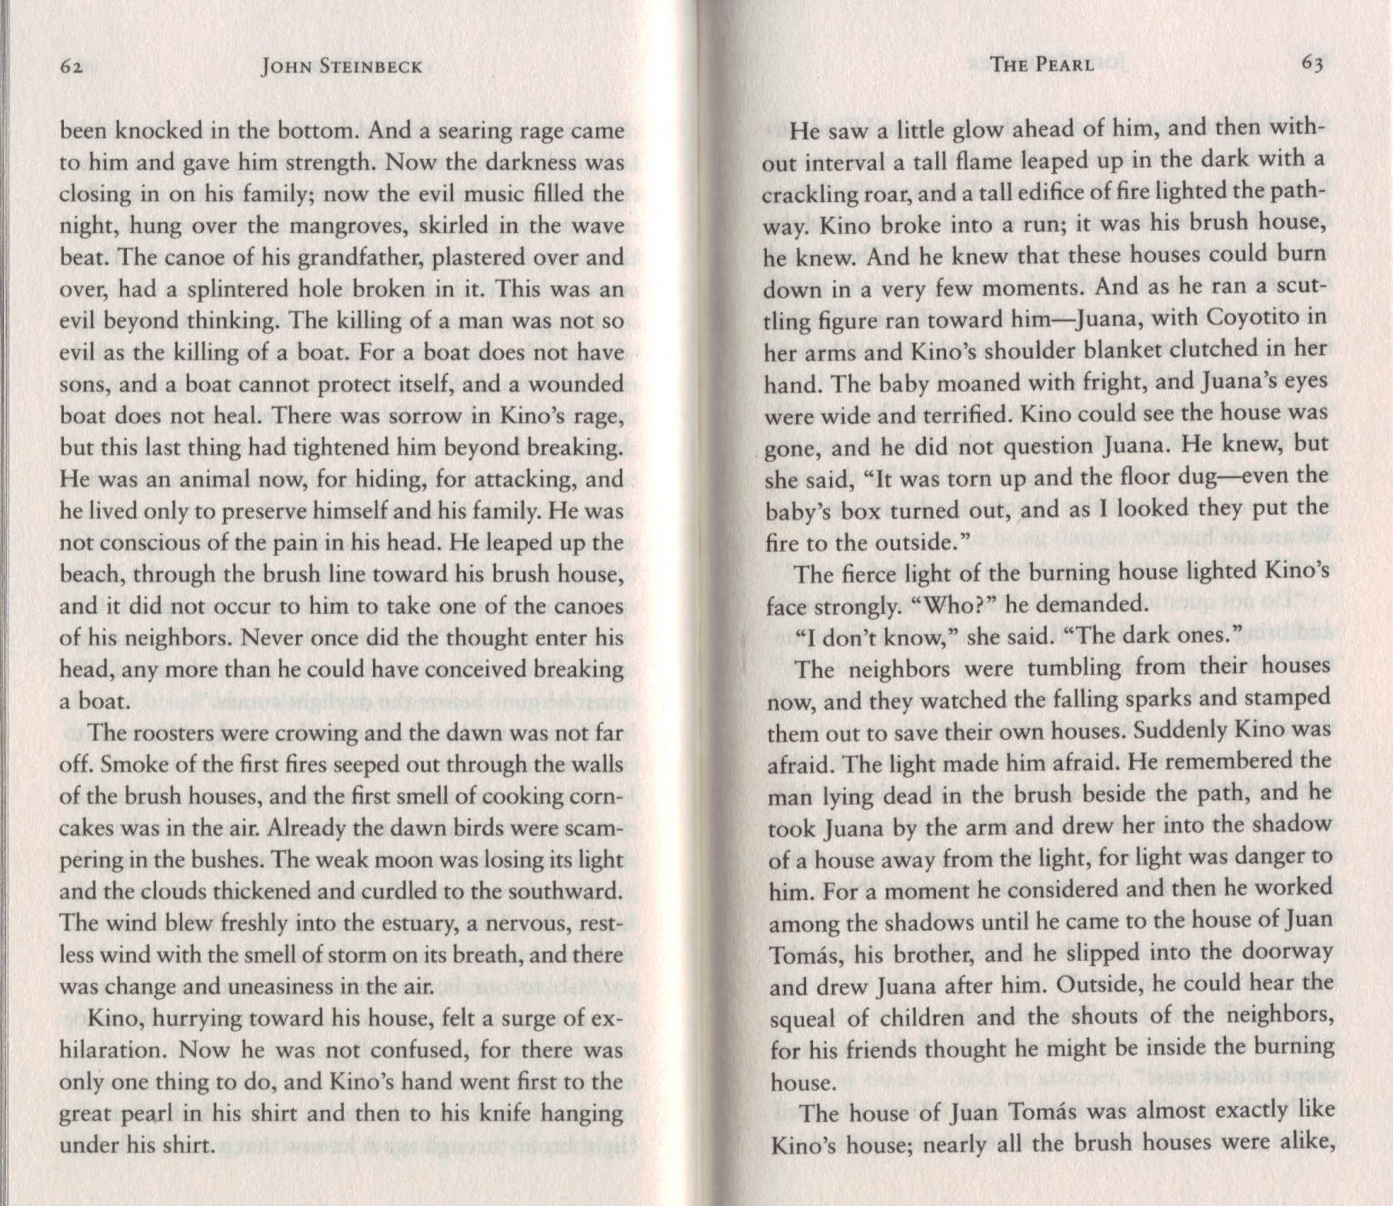

Theme: Music

DO YOU AGREE THAT “THE KILLING OF A MAN [IS] NOT SO EVIL AS THE KILLING OF A BOAT?” WHY OR WHY NOT?

WHAT DOES THIS SAY ABOUT KINO?

Theme: Greed and Corruption

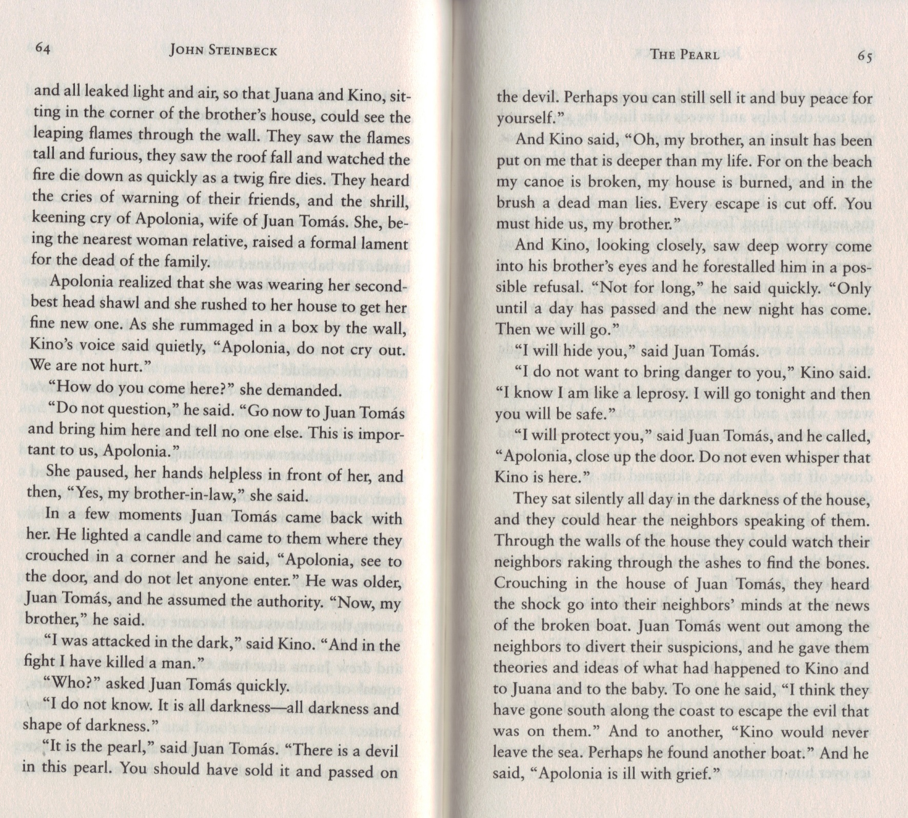

Theme: Greed and Corruption

Theme: Greed and Corruption

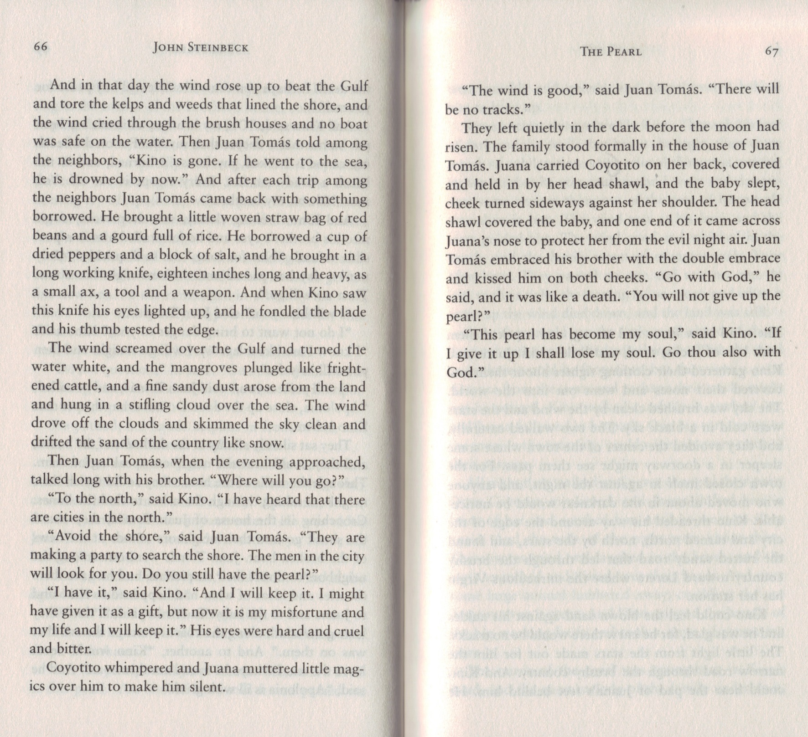
1) WHAT DOES THIS SAY ABOUT THEIR COMMUNITY?

2) HOW IS THEIR PHILOSOPHY DIFFERENT FROM THE PEOPLE IN THE TOWN (THE DOCTOR AND THE PEARL BUYERS)?

WHY IS KINO EXCITED ABOUT THE KNIFE?

Theme: Greed and Corruption

Theme: Greed and Corruption
WHAT DOES KINO MEAN BY THIS?

