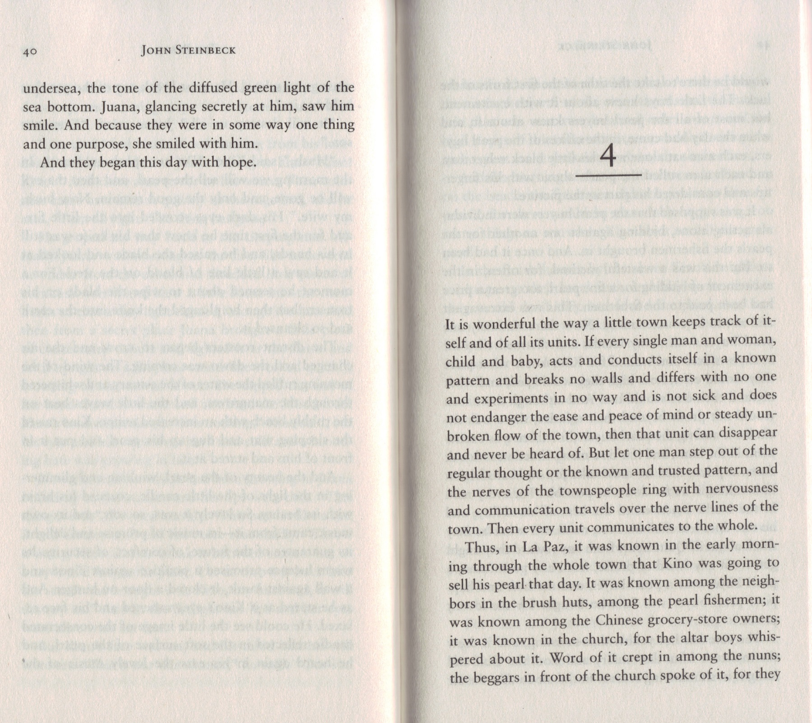

WHAT IS THE AUTHOR SAYING IS NECESSARY FOR SOCIAL HARMONY?

IS THIS TRUE, IN YOUR EXPERIENCE?

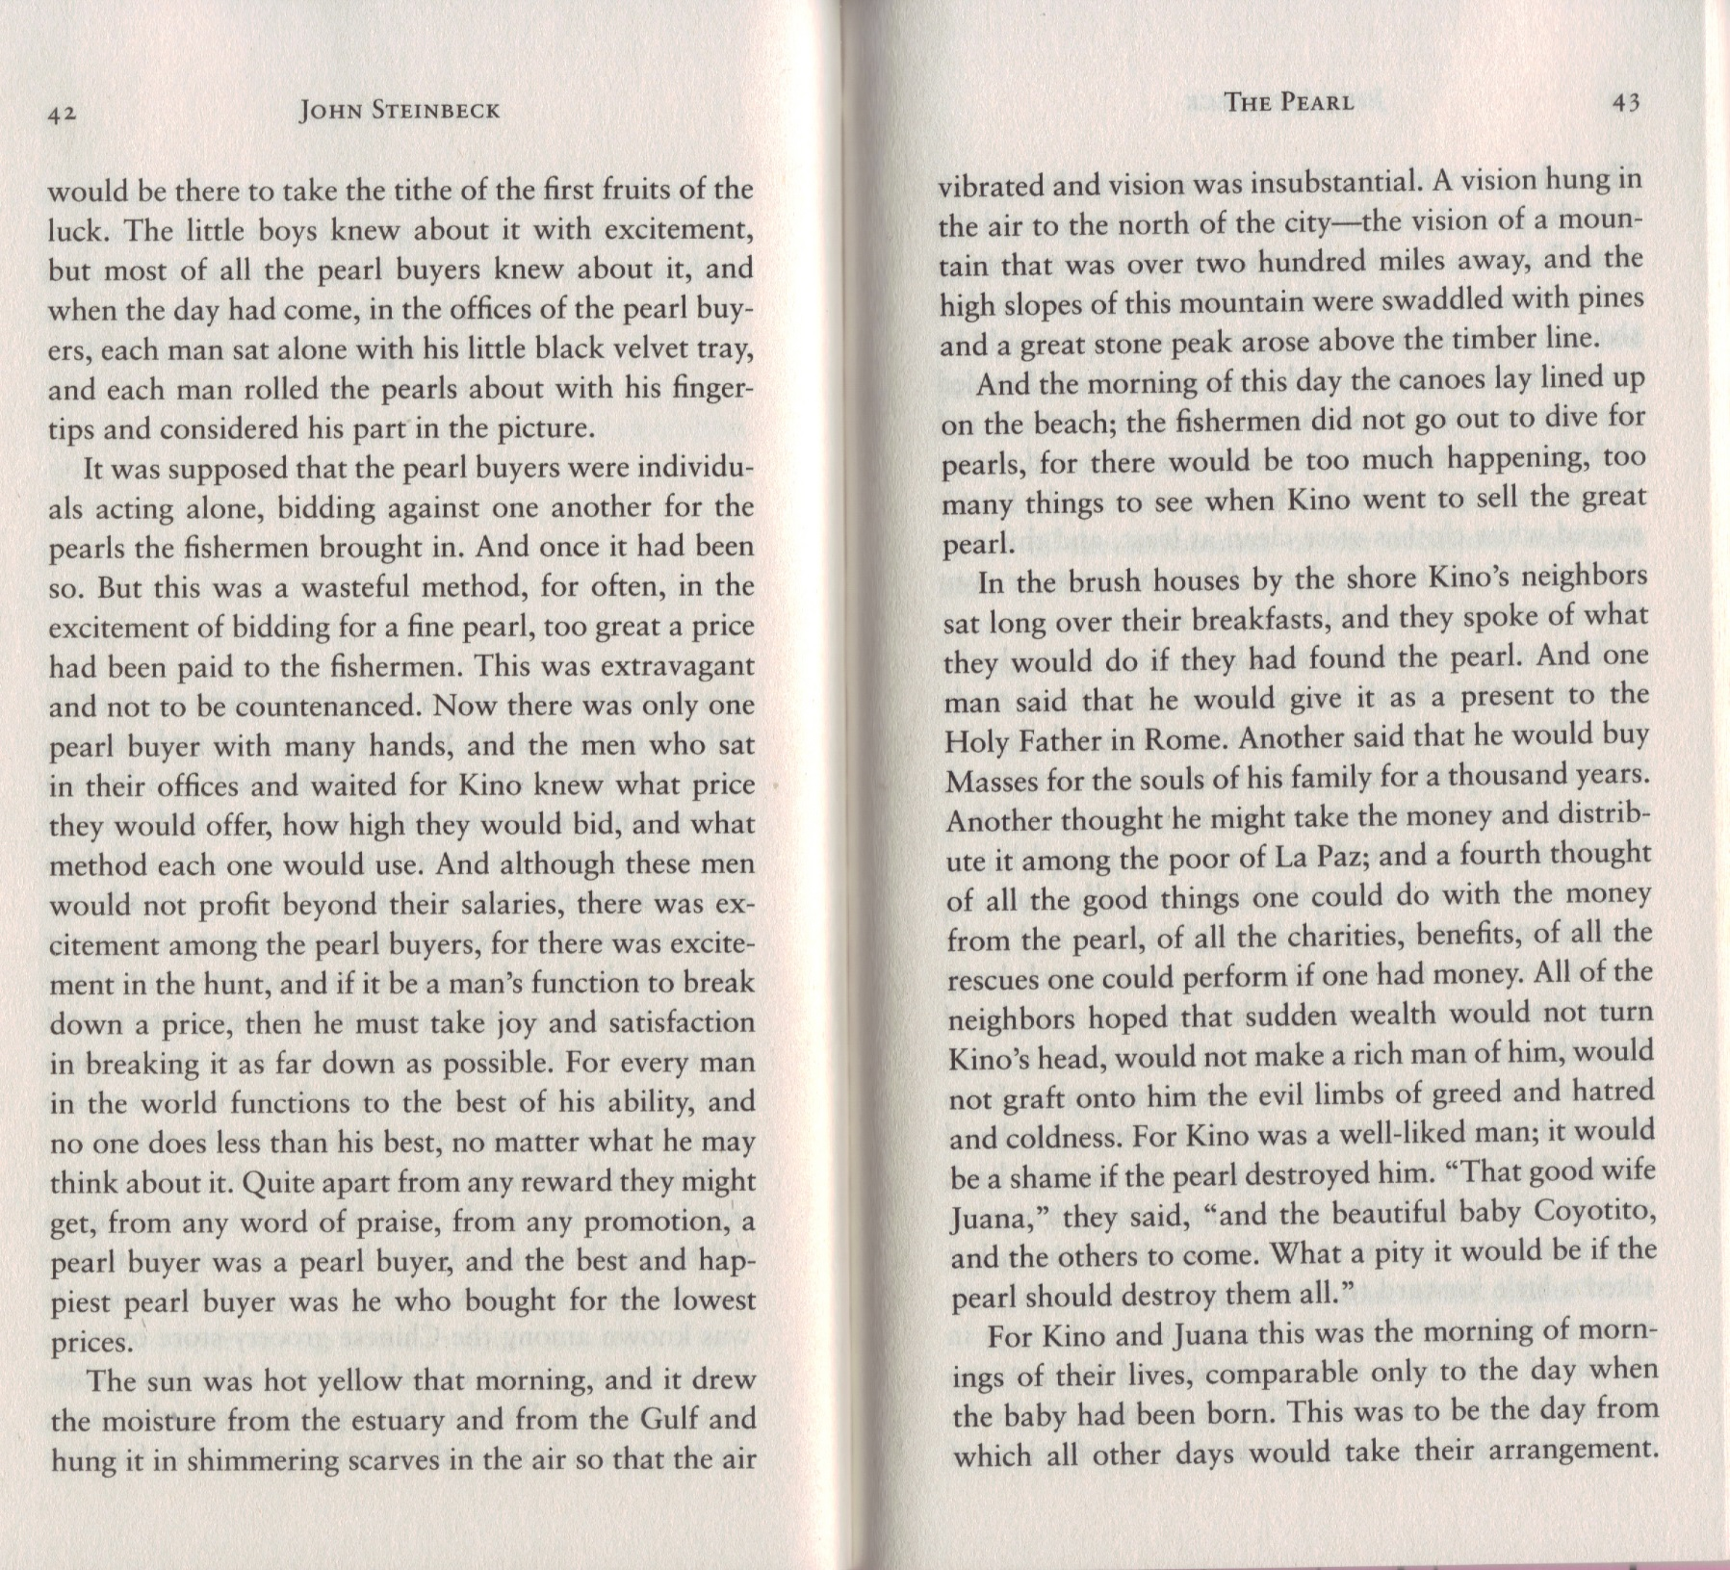

A tithe is an amount of money paid to the church as charity.

EXPLAIN HOW THE SYSTEM IS RIGGED AGAINST THE PEARL FISHERMEN:

IS THIS TRUE?

Beautiful!

WHAT DOES IT MEAN THAT THE BABY’S SCREAMS ARE TURNING INTO MOANS?

Some people in the Church said that for a soul to get to Heaven, a certain number of prayers needed to be said. The dead person’s relatives could pay for Masses (Catholic Church services) to speed that process up.

Theme: Greed and Corruption

WHAT DOES THE METAPHOR “MORNING OF MORNINGS” MEAN?
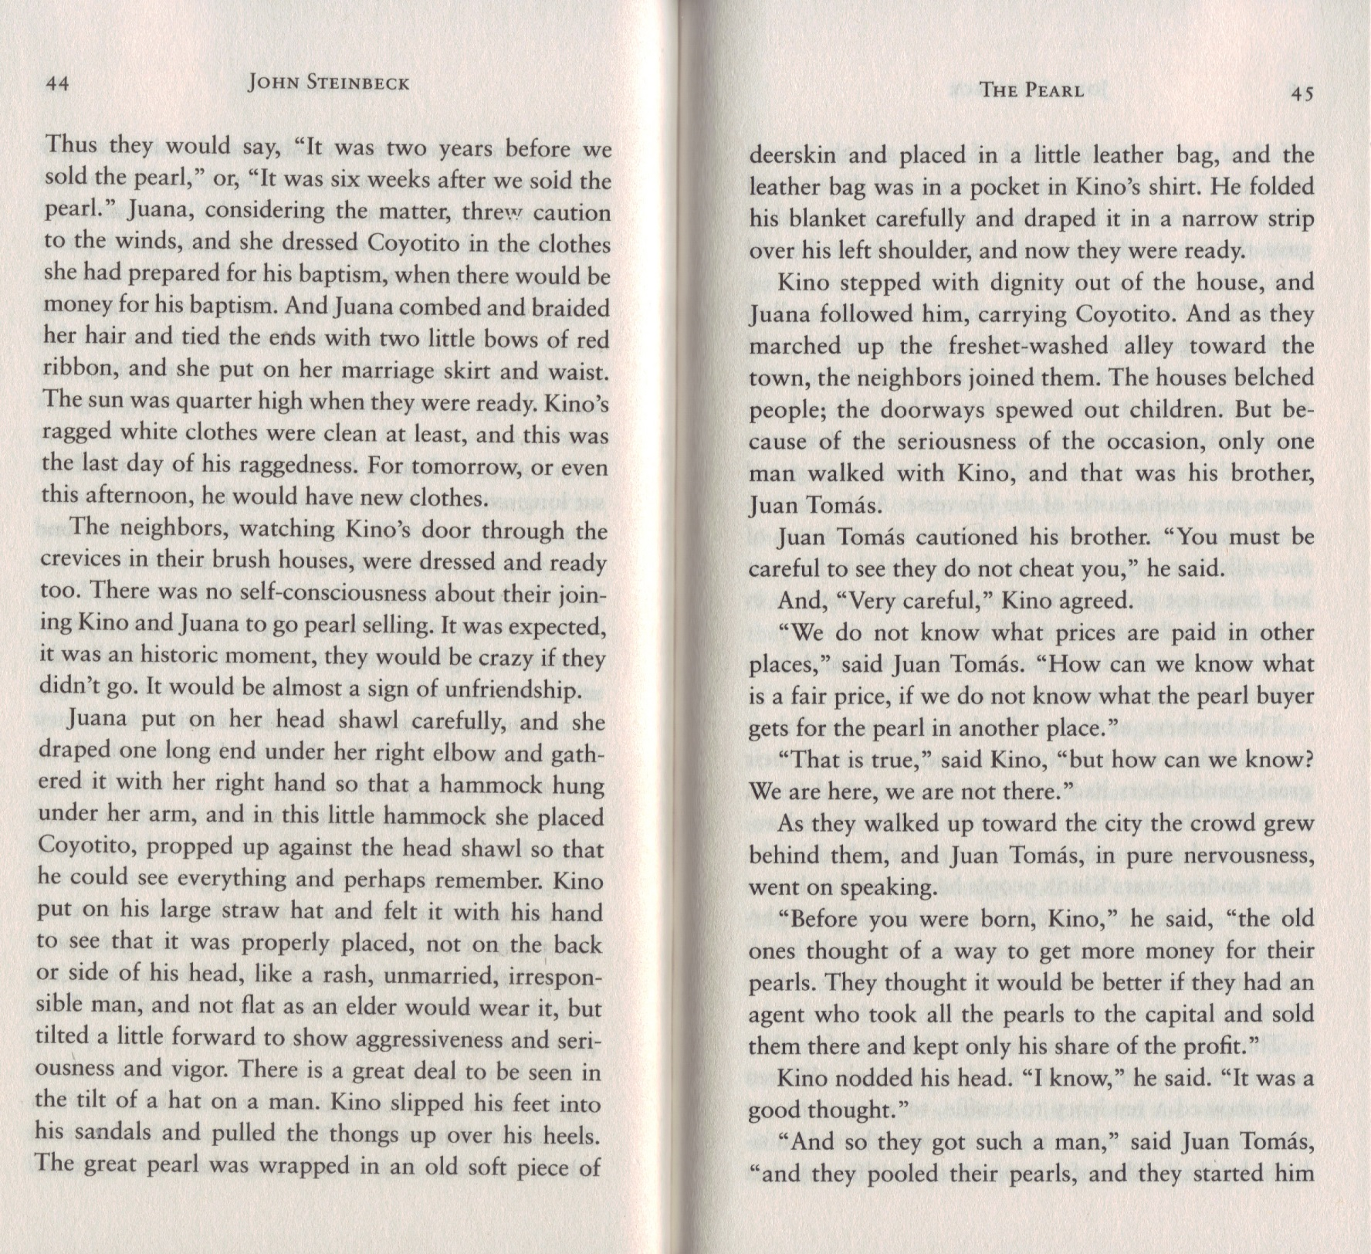

Baptism is a ceremony in which a person formally becomes a member of a faith.

EXPLAIN WHAT YOU CAN TELL ABOUT A PERSON FROM THE TILT OF HIS OR HER HAT:

Theme: Colonialism and Oppression
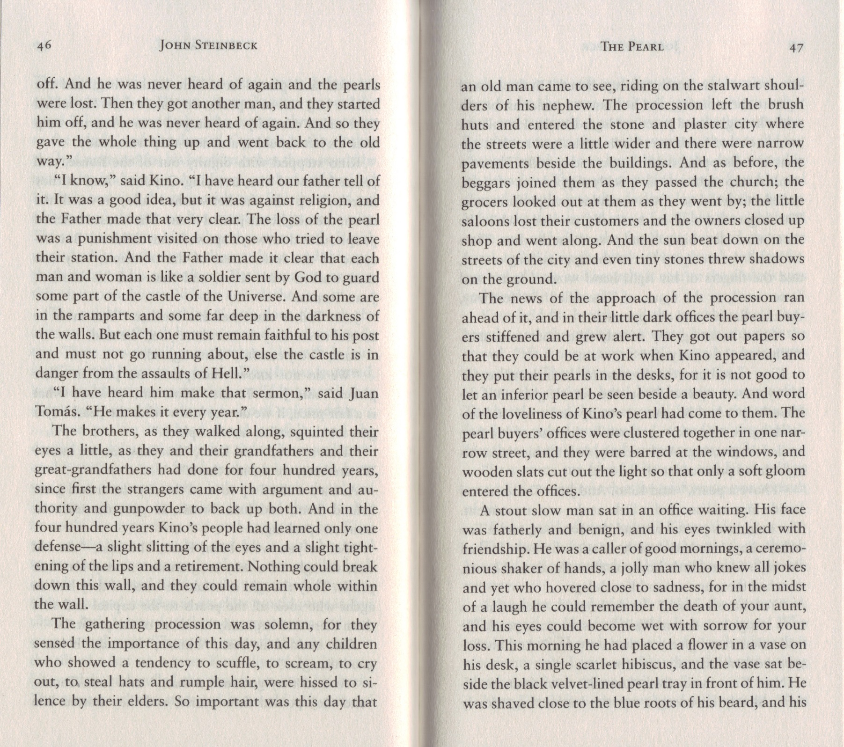

Theme: Colonialism and Oppression

SO THE PRIEST IS ESSENTIALLY TELLING THE POOR PEOPLE THAT GOD WANTS THEM TO REMAIN POOR. WHY WOULD HE TELL THEM THAT?

Theme: Colonialism and Oppression

HOW IS JUANA CHARACTERIZED?

WHY WOULDN’T THE DOCTOR COME?

Theme: Music

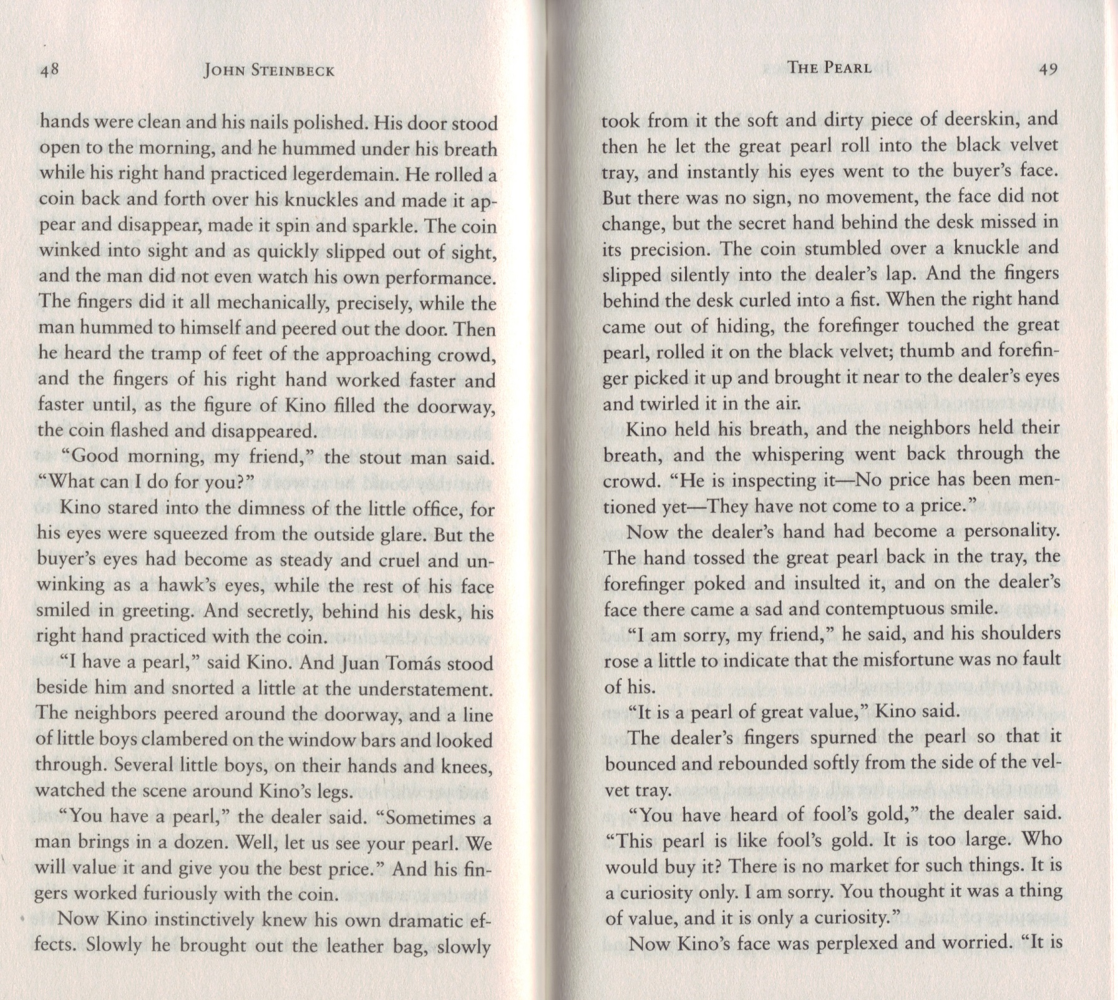

“Legerdemain” means “slight-of-hand” – like magic or feats of dexterity.

Understatement is a literary technique in which the truth is minimized – kind of the opposite of hyperbole.

WHY DID THE PEARL DEALER’S FINGERS CURL INTO A FIST?

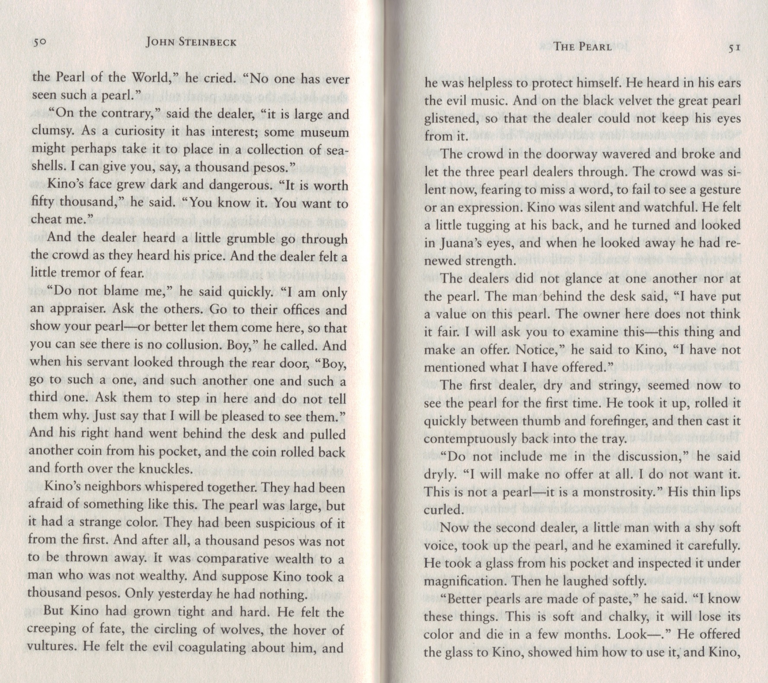

Theme: Colonialism and Oppression

Theme: Music

Theme: Colonialism and Oppression

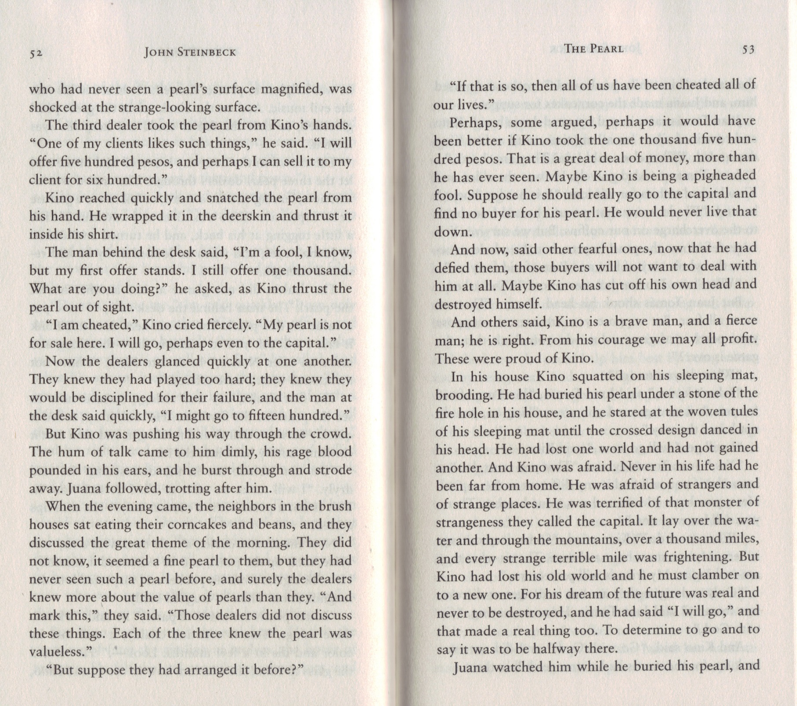

HOW IS THE DEALER TAKING ADVANTAGE OF KINO?

HAVE THEY BEEN CHEATED ALL OF THEIR LIVES? IF SO, HOW?

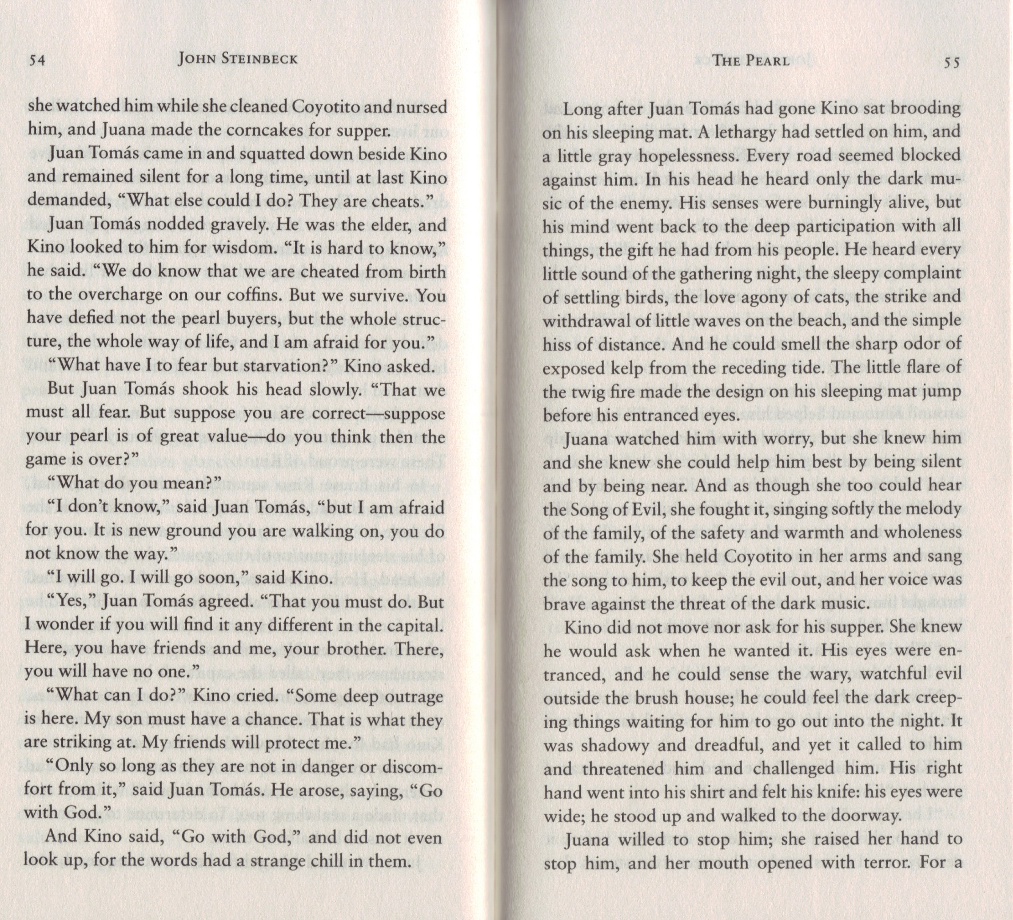

EXPLAIN WHAT THIS METAPHOR MEANS:

Theme: Greed and Corruption

Theme: Music

Theme: Music
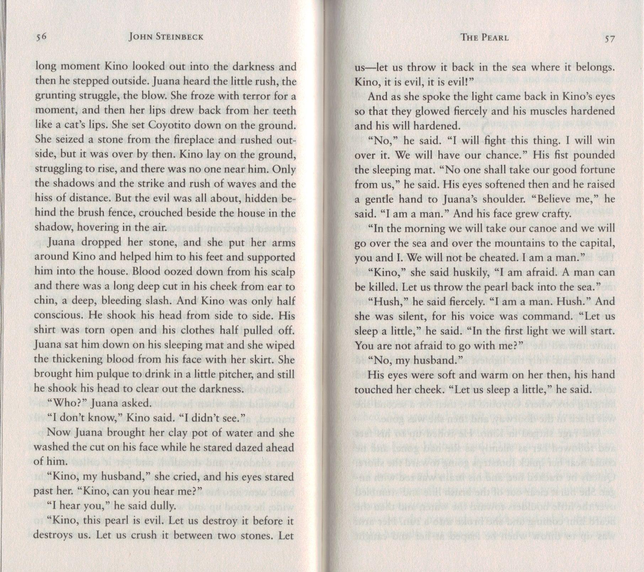

This is an example of personification – the evil is treated like a character or human being.

Theme: Greed and Corruption

WHY DOES KINO KEEP REPEATING THAT HE IS A MAN?

