Name: Date: Period:
Autobiography of a Reader - Writing Assignment
Step 1:
Make a list of ten memories that you have of reading. Your list could include:
- How you learned to read
- A book that really impacted you
- Struggles that you have had with reading
- How you feel about books and reading

Here’s my list: And here is a picture of me with
all the books I read in 2013.
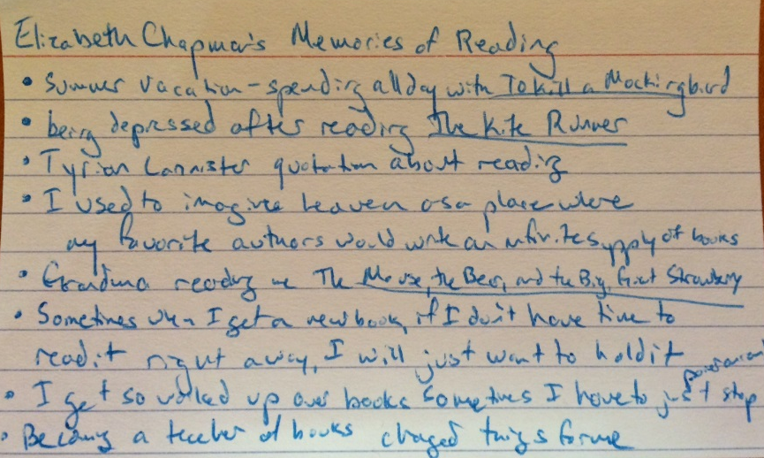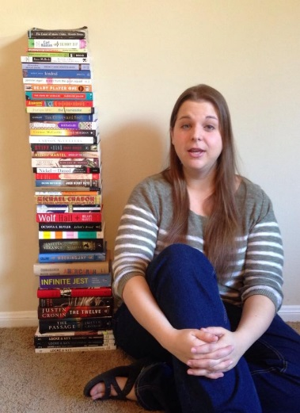

Write your list here:

Step 2:
Your homework assignment for tonight is to weave some (not necessarily all) of those memories together to write an autobiography of yourself as a reader.
Some specifications for this assignment:
- The title of your work should be Autobiography of a Reader: Your Name
- It should be ~500 words.
- If it’s possible, I would prefer for it to be typed.
- I would like for your to try a full-circle ending, like Shermie Alexie uses in his essay (started and ending with the image of Superman), and like I have attempted to do with the bicycle in my autobiography.

Here’s mine:
Autobiography of a Reader: Elizabeth Chapman
I wish I could tell you that I fell in love with reading when I discovered a musty old library in a crumbling, ivy-covered mansion where I had been sent to live with some distant and eccentric relatives after a childhood tragedy, but the truth of the matter is that I wanted a bicycle. On the street where I actually lived, in a lower-middle class suburban neighborhood, there was a man who had recently been released from prison, and so my mother refused to buy me a bike or even let me out in the front yard.
That year, third grade, my school began something called the Accelerated Reader Program. For every book you read, you could take a test on the library’s bulky computer and earn points to “buy” stickers, erasers, plastic jeweler, and other childhood treasures. But that wasn’t all. One morning I heard the principal announce over the loudspeaker that the student in the school with the most points would win a bicycle. This was my chance! If I won the bike, my mother would have to let me ride it out into the neighborhood.
Mr. Brown, the soft-voiced librarian, helped me to find my first book for the competition: The Hobbit, worth 10 points. And as I read about the adventures of Bilbo, the trickery of Gollum, the wizardry of Gandalf, a kind of magic started working on me. Before long, I was staying up late with a flashlight under the covers of my bed, dragging my heavy eyelids up so that I could finish just one more chapter of Little Women (what was Jo’s problem?! why couldn’t she just love Laurie?!).
In seventh grade, this got me into some trouble. I was reading Sybil, the true story of a women with Multiple Personality Disorder, and it was so good, I. Just. Couldn’t. Stop. One afternoon I was in trombone sectionals, and the assistant band director, Mr. Loud (yes, he was really called Mr. Loud), was droning on and on about the piece for our spring concert, and I could just feel that book under my seat. I wiggled it out in front of me with my foot and then stealthily opened it to where I had left off with the slide of my trombone. Before I knew it, Mr. Loud was six inches in front of my face, living up to his name.
I discovered that some books could be so powerful they would exert a physical force on me. I had a mini-brain-explosion from the conclusion to Orson Scott Card’s Ender’s Game, Christopher Moore’s Lamb: The Story of Biff, Christ’s Childhood Pal made me laugh so hard I peed a little bit, and Sandra Cisneros’ Caramelo helped me understand the shape of my own heart. When I grew up and got a real job where I made real money and could buy all (or almost all) of the books I wanted, I often didn’t have time to read, so I would go to sleep with the unopened book curled up next to me, as comforting as a teddy bear.
I didn’t win the bicycle. In the end, I came in Third Place in the entire school, which was not because I didn’t read enough, but instead because I started reading books that were not on the Accelerated Reader list. It wasn’t much of a loss because, truth be told, I was now happier indoors with a book than I would have been out in the neighborhood. That summer, I finished To Kill a Mockingbird in a single sitting, watching the sun rise and set from the couch where I was reading.

That was Mr. Loud’s one and only year at Webster Intermediate. The trombones and euphoniums gave him a really hard time, and I remember another afternoon he got so frustrated he walked off the conductor’s stand and locked himself in the band office. While he was in there, Steven Zimmerman stole his sheet music.

