The Glass Castle – Character Analysis
Draw clothes and features appropriate for your character. Answer each question with a complete sentence and two quotes as textual evidence (including a page number).
How does your character behave? (Think in terms of virtues and vices.)
What motivates your character? (Think in terms of hopes, desires, and fears.)

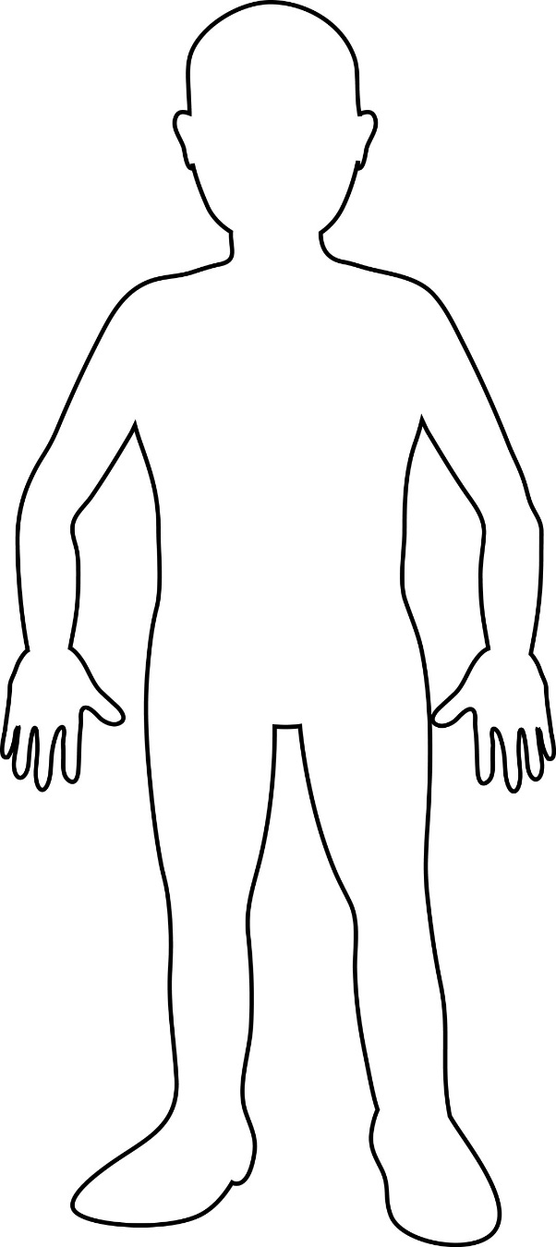

What does your character’s speech say about him or her?
What is your character’s greatest internal conflict?

